Assessment of Customer Satisfaction for High-end Pakistani Restaurants in London
[Name of Student]
[Name of institute]
Word count: 13,777

Executive Summary
The current investigation outlines valuable knowledge pertaining to the evaluation of the customer satisfaction ratio for high-end Pakistani restaurants based in London. The study considered 10 high-end Pakistani restaurants which are recognized to conduct secondary analysis with qualitative and quantitative methodology. Based on customer reviews for each restaurant, an analysis of ratings provided to Pakistani restaurants based on food quality and customer services was performed. It is evident from secondary analysis that based on excellent staff services and tasty cultural food dishes, highly recommended Pakistani restaurants include Karachi cuisine, Lahori Kebab house, Zayna, Lahore village, Taste of Peshawar, etc. Additionally, lower-rated restaurants include Namaste Highgate, Dar, Al-Kareem, Lahori Nihaari, etc., which are rated on average and below average rating based on food quality and staff service offered within the restaurant.

Table of Contents
1 Executive Summary 2
2 Chapter:1 Introduction 6
2.1 Research Background 6
2.2 Rationale of the study 8
2.3 Company Analysis 8
2.4 Research question 9
2.5 Research objectives 9
2.6 Project structure 9
2.6.1 Chapter:1 Introduction 9
2.6.2 Chapter:2 Literature review 10
2.6.3 Chapter:3 Research methodology 10
2.6.4 Chapter:4 Findings and Discussion 10
2.6.5 Chapter:5 Conclusion and Recommendations 10
3 Chapter:2 Literature review 10
3.1 Introduction 10
3.1.1 Significance of customer service in Pakistani Restaurants of London 11
3.1.2 Interior designing and customer satisfaction in Pakistani restaurants in London 12
3.1.3 Food quality services for Pakistani restaurants in London 13
3.1.4 Growth ratio of Pakistani restaurants in London 14
3.1.5 Increasing South East Asian Cultural Food Trends in London 16
3.2 Theoretical framework 17
3.2.1 SERVQUAL model theory 17
3.2.2 Service recovery Paradox theory 18
3.2.3 Consumer behavior theory 19
3.2.4 Theory of buyer behaviour 22
4 Chapter:3 Research methodology 24
4.1 Introduction 24
4.2 Research paradigm 24
4.3 Research approach 26
4.3.1 Inductive 26
4.3.2 Deductive 27
4.4 Research strategy 27
4.4.1 Interpretivism 27
4.4.2 Positivism 28
4.5 Research Methodology 29
4.5.1 Qualitative methodology 29
4.5.2 Quantitative methodology 29
4.6 Data collection 30
4.7 Sampling method 30
4.8 Ethical consideration 31
4.9 Access issues 32
4.10 Research limitations 32
4.11 Time horizon 32
5 Chapter:4 Findings and Discussion 32
5.1 Qualitative findings 32
5.1.1 Taste of Peshawar 33
5.1.2 Karachi cuisine 35
5.1.3 Namaaste highgate 38
5.1.4 Spice Village Tooting 40
5.1.5 Zayna 42
5.1.6 Lahore Village 44
5.1.7 Lahore Kebab House 46
5.1.8 Dar's 48
5.1.9 Al Kareem 49
5.1.10 Lahori Nihari 51
5.2 Qualitative Discussion 52
5.2.1 Taste of Peshawar 52
5.2.2 Karachi cuisine 54
5.2.3 Namaaste highgate 55
5.2.4 Spice Village Tooting 57
5.2.5 Zayna 60
5.2.6 Lahore village 61
5.2.7 Lahore Kebab House 63
5.2.8 Dar 64
5.2.9 Al Kareem 66
5.2.10 Lahori Nihari 67
5.3 Quantitative findings 67
5.4 Quantitative discussion 70
6 Chapter:5 Conclusion and Recommendation 71
6.1 Key findings 71
6.2 Achievement of research objectives 72
6.2.1 To critically evaluate the impact of ambience/physical aesthetics on customer satisfaction in high-end Pakistani restaurants based in London. 72
6.2.2 To identify the role that food quality plays in patronage of the restaurants 72
6.2.3 To critically review the effect of customer service on customer retention/repeat patronage. 72
6.2.4 To recommend practices that can improve customer retention in high-end Pakistani restaurants in London. 73
6.3 Areas of further research 73
6.4 Limitations of the study 73
6.5 Recommendations 73
7 Chapter 06: Reflection of Professional Practice 75
7.1 Introduction 75
7.2 Feelings 75
7.3 Evaluation 75
7.4 Analysis 75
7.5 Conclusion 76
7.6 Action Plan 76
8 References 77
9 Appendix 94
9.1 Reflective blogs 94

Chapter:1 Introduction

Research Background
The hospitality industry has been growing rapidly due to certain operational measures adopted to accommodate customer satisfaction. Operational strategies adopted by restaurant businesses significantly contribute to retaining consumers for longer durations. Food is a cultural element offered by restaurants, hotels, etc. (Hiamey et al., 2021). Customer satisfaction depends on the quality and taste associated with food items and beverages offered by high-end restaurants. The potential reputation for expensive restaurants is associated with a driven approach consumed to fulfil customers' respective choices. Food restaurants have been majorly recognized as valuing customers' cultural aspects by offering tasty food items; the strategic objective is to retain clients (Gallarza-Granizo et al., 2020).
High-end food restaurants in London offer dishes that represent the cultural tastes of Southeast Asia (Lane and Opazo., 2023). By offering hilal food items to Pakistanis, their well-being is maintained. Pakistani people in London search for restaurants that have created a valued reputation and that offer sustainable food dishes to people from various origins. By offering quality food items, local tastes are offered to visitors within restaurants (Hernández-Rojas and Huete., 2021). Restaurant businesses have been majorly responsible for fulfilling environmental aspects and corporate social responsibilities. Business growth and profitability depend on the extent of Customer satisfaction rate. With well-driven initiatives, i.e., cultural authenticity, quality cuisine, beverages, and hotel services are offered based on people's respective visits.
The study of Danish et al.(2023) concludes that the popularity of local Pakistani food dishes in London demonstrates how well the restaurant industry has been able to respond to customers' values based on their cultural preferences. Customer satisfaction depends on staff dealing, quality food items, internal infrastructure, etc., maintained by high-end restaurants. The internal atmosphere and layout within restaurants have a positive impact on customers. Client revisit depends on how well operational staff in hotels and restaurants have been able to serve and cater hoteling services (Mahafzah et al.,2020). High-end Pakistani restaurants across various regions of London have invested in restaurant design to provide sustainable ambience to maximize the satisfaction of visitors.
Staff members who work as front-line employees who accommodate services to clients are highly trained to engage, convince, and fulfil the respective values of customers based on their visits to restaurants. With the recruitment of highly qualified and talented staff, quality services are offered across respective restaurants in London (Ghani et al., 2022). Well-furnished interiors improve clients' dining experience, and with quality interior design, customers' satisfaction is valued. Chefs working in kitchens have expertise in preparing local Pakistani cuisines with a desi touch within food items to offer cultural dishes (Gupta., 2020). Greeting guests, accompanying them to reserved tables, providing quality food, dishes and beverages on time, etc., are restaurants' values to fulfil customers' satisfaction. High-end restaurants have been working consistently to deliver quality services to guests on their visits.
Revisits from clients demonstrate loyalty towards restaurants to the extent that hotel services marginally generate word of mouth, attracting new clients to respective restaurants. High-end restaurants are well-recognized for offering foreign food items to European visitors and cultural dishes to Asian visitors (Sann et al., 2020). A restaurant's profitability is highly dependent on the relation of trust created with clients based on their respective visits to eat cultural food dishes. Convenience due to the efficient availability of local food items within high-end restaurants in London attracts Pakistanis and Indian people to visit on a regular basis.
During Pakistani cultural events, these restaurants offer food dishes at discount prices to maximize customer satisfaction. To create value of trust, quality ingredients are used to prepare cuisine (Ali et al.,2020). Discount offers provided due to cultural events attract a large amount of Southeast Asian visitors across these high-end restaurants. A higher proportion of Pakistani locals residing in London visit luxurious restaurants to obtain a quality cultural taste, which they are fond of (Dey et al., 2019).

Rationale of the study
The rationale for conducting an investigation on high-end Pakistan restaurants across London is to identify the cultural and social environment practised across these restaurants during customers' respective visits. With vast significance for presenting cultural cuisine within high-end restaurants, the hotel industry aimed to accommodate Pakistani clients with value-driven services across their restaurants at each customer's visit to maximize their satisfaction ratio and to maintain sustainable long-term relationships with stakeholders (Mokhtar et al., 2021). Based on market analysis, it has been predicted that Pakistani food items have obtained higher popularity within London due to the increasing ratio of Southeast Asian customers who visit these restaurants.
This investigation will provide a thorough understanding of multiple factors that paved the way for high-end restaurants to strategize their operational dimensions to value Pakistani customers within their respective hotels. The study will provide in-depth knowledge to readers about how strategic decision-making has a pivotal impact on customer retention across the hotel industry in London. Additionally, I am primarily familiar with the extent to which high-end Pakistani restaurants in London have been able to implement transformed tactics to value customers' respective expectations based on their visits.

Company Analysis
With a higher proportion of high-end Pakistani restaurants in London, the hotel sector has been responding significantly to clients' choices and their cultural values. Pakistani restaurants in the region include Taste of Peshawar, Karachi Cuisine, Spice Village tooting, Lahore Kebab House, Miran Masala, etc. (Chaudhry et al., 2023). The availability of Pakistani food restaurants accommodates the food tastes of local communities of Pakistan with a desire to experience cultural food items. Due to the large number of Pakistani restaurants in London, consumers have a wide variety of choices to taste the cuisines and beverages that they value the most.
With timely meals, i.e. breakfast, brunch, lunch, dinner, etc., a wide variety of food dishes are offered at various price ranges. By categorizing cultural dishes based on dietary restrictions, food items and beverages are distributed based on vegetarian-friendly, gluten-free options, halal, etc. (Cámara et al., 2021). Customers can order food cuisines as per their tastes and values. The main features of restaurant services across these high-end restaurants consist of seating, takeout, reservations, table service, etc. By valuing customers' choices, quality-driven services are accommodated across each restaurant.

Research question
- Is Pakistani restaurants’ interior design and service quality a major factor in the increased satisfaction of patrons?

Research objectives
- To critically evaluate the impact of ambience/physical aesthetics on customer satisfaction in high-end Pakistani restaurants based in London.
- To identify the role that food quality plays in patronage of the restaurants
- To critically review the effect of customer service on customer retention/repeat patronage.
- To recommend practices that can improve customer retention in high-end Pakistani restaurants in London.

Project structure
The structure of the dissertation consists of the following:

Chapter:1 Introduction
The introduction of the research would set the structure of the topic by exploring the rationale behind conducting an investigation on a particular research aim. By presenting objectives and research questions, readers will get to know about significant understanding related to what the researcher needs to accomplish during the course of research.

Chapter:2 Literature review
With a theoretical framework, the researcher will justify the research problem by including meaningful knowledge that would assist readers in understanding the rationale of the topic. By reviewing past research articles, the researcher will demonstrate valuable information pertaining to how high-end restaurants in London have assessed customer satisfaction by valuing Pakistani visitors across their restaurants.

Chapter:3 Research methodology
Research methodology provides readers with knowledge about the research method used while investigating the topic. The selection of research design and research approach enables a researcher to examine the objectives of the study to accomplish the goal of the research. Additionally, with the data collection technique, valuable primary or secondary data would be extracted while justifying the rationale of the study.

Chapter:4 Findings and Discussion
This chapter provides relative findings obtained by a researcher with a selection of research design and data collection methods considered within the methodology. By relating findings to theoretical knowledge, research would include their results in this section of the study.

Chapter:5 Conclusion and Recommendations
By summarizing overall research findings, researchers will conclude their results pertaining to the topic while investigating how well high-end Pakistani restaurants have been able to assess and value customers' respective preferences in London. Additionally, based on the findings of the study, recommendations would be provided to future researchers.

Chapter:2 Literature review

Introduction
This section of the investigation will provide readers with in-depth knowledge by structuring a theoretical framework to demonstrate significant knowledge about how high-end Pakistani restaurants in London have been able to respond to consumers' respective values by offering them sustainable and quality-driven services during their visits.

Significance of customer service in Pakistani Restaurants of London
Customer’s trust depends on value-added services offered based on their respective visits to restaurants to taste local cuisines preferred by Pakistani communities in London (Adekunle and Filson., 2020). Staff engaged in serving customers influence clients to revisit and share their experiences with their associations. Impression imposed by restaurants on guests describes how well strategies have been practised to retain clients for longer durations (Nyamekye et al., 2023). The extent of services offered by hotel staff requires attentiveness, etc., to deliver rapid responses to customers. Customer loyalty requires staff engagement with visitors to accompany them to accommodate their values and choices.
Foreign visitors accompany local food dishes prioritized by Pakistani communities across restaurants in London as, based on word of mouth, European clients are attracted to experience food cuisines preferred by local communities in London (Shultz.,2023). Pakistani restaurants are executed by local communities who have migrated to the UK. Based on relationship trust, quality-driven services with value-added dimensions are offered to clients on their respective visits across these restaurants. Cultural dishes are offered to maintain long-term bonding with customers. The significance of Southeast Asian cuisines across London has paved its value across the hospitality industry (Mtshokotshe., 2020). By promoting Pakistani food culture, European citizens are demonstrated with cultural values prioritized by non-European citizens.
The existence of Pakistani food restaurants across London is from previous decades as local communities residing in London display a cultural touch by presenting tasty cuisines as per clients' choices (Zeb et al., 2021). The strategic value associated with these Pakistani restaurants is to maintain trust with their clients by presenting them with unique dishes that would raise their satisfaction rate (Javed et al., 2021). Additionally, offering them similar services provided across local restaurants in Pakistan has been adopted to equip them with comfort. Pakistani consumers who are fond of exploring food dishes visit Pakistani restaurants to experience taste by distinguishing the extent of quality provided within those restaurants (Amidi et al.,2022). A crowd of locals is more on cultural and religious occasions as people reserve family bookings to enjoy with their associates. Social gaps are minimized based on services offered by restaurant staff on customers' respective visits.
Local communities living in foreign countries are fond of eating food items and normally consume three main meals, i.e., breakfast, lunch, and dinner. Traditional Pakistani cuisine consists of higher fat levels, sugar levels, etc., which would be adverse for patients. However, youngsters and adults consume these food items on a regular basis. European citizens avoid eating food items that consist of a higher ratio of fat, oil and sugar (Szypowska et al.,2023). Local consumers avoid consuming food items by visiting European restaurants due to the risk of availability of no hila food items. However, within Pakistani restaurants, quality food items that consist of Hilal ingredients are offered (Helal., 2022).
South East Asian communities, including Indians, Bangladeshis, etc., experience food cuisines offered within Pakistani restaurants due to similar cultural values (Chaudhry et al., 2023). With the increasing ratio of local restaurants, it has become convenient for local communities residing in London to experience their preferred food dishes that are conveniently available within restaurants within their region. By offering dining and takeaway services, customers' choices are fulfilled based on their respective visits to Pakistani restaurants (Ali et al.,2021). With a wider growth ratio of Pakistani restaurants, multi-cultural dimensions are promoted across London. People prefer to visit restaurants and convince their associations to experience food items that they haven't experienced yet (Le et al., 2022). The increasing ratio of Europeans who visit these restaurants is due to the brand reputation created by local communities by introducing cultural aspects admired by them by constructing these restaurants within the UK.

Interior designing and customer satisfaction in Pakistani restaurants in London
The internal atmosphere within high-end Pakistani restaurants in London potentially impacts customers' visits to these restaurants (Ferdous and Mim., 2021). Internal decoration infrastructural layout impact positively engages customers during their particular visits and influences them to obtain services offered within those restaurants. Investment decisions within high-end Pakistani restaurants with internal designing and restructuring cultural dimensions by presenting historical Pakistani cultural views would attract customers' attention (Riaz., 2022). With visual representation, customers would satisfied with a pleasant experience by representing cultural values, which would assist the operational management of hotels to maintain sustainable long-term relationships with Pakistani locals residing in London.
With an eye-catching internal atmosphere, an enjoyable dining experience would raise the desire to revisit hotels. High-end Pakistani restaurants are constructed with the aim of demonstrating cultural values based on food dishes and interior design (Oh and Kim., 2020). Interior decoration points to be the first impression of visiting clients who praise and positively respond by verbally communicating with the hotel staff about the significance of Pakistani culture. Multi-cultural dimensions represented across high-end restaurants assist hotel staff in maintaining engagement with customers.

Food quality services for Pakistani restaurants in London
With internal infrastructure, quality maintenance within food items would raise potential satisfaction among consumers. Presenting chosen food dishes to clients would positively influence additional food orders (Annaraud and Berezina., 2020). Pakistani food restaurants in London offer quality and hygienic food items that are cooked within quality supervision to ensure the health and safety of visitors. By using quality food ingredients, customers' well-being has been prioritized (Batat and Addis., 2021). By adopting standards of the procedure with preservation of raw materials, i.e. ingredients, etc., the quality production of food dishes as per clients' request has been fulfilled (Chen et al., 2022). Regular visits conducted by food inspectors supervise food items in a timely manner to avoid health hazards. High-end Pakistani restaurants legally registered in London have been adequately fulfilling health standards and adopted ethical considerations to ensure stakeholders' expectations.
With the sustainable implementation of ISO standards, quality supervision has been ensured for preserving, preparing, and delivering food items within restaurants (Okpala and Korzeniowska., 2023). Food inspectors report to quality assurance managers by constructing evaluation reports that demonstrate overall operational initiatives practised by operational staff. In case of any customer complaints, quality assessments are performed by properly evaluating food items to ensure quality deliverance (Haleem and Sufiyan., 2021). Food inspectors and quality assurance managers are responsible for overseeing and monitoring regulatory actions to provide quality cuisines as per the client's requests.
Cultural food dishes offered in high-end Pakistani restaurants in London consist of high-quality taste that refreshes customers and their visiting experience (Graves., 2021). Famous Pakistani cultural dishes offered in restaurants in London include Chicken Karahi, Nihari, biryani, Chicken korma, beef korma, Beef Karahi, etc. (Massa., 2023). These food cuisines are adored by Pakistani visitors who experience food items across respective restaurants in London. Additionally, beverages are offered, including lassi, chai, etc. Cultural values maintained across these restaurants are the essential rationale for their growth, by maintaining consistency within food dishes prepared by experienced Pakistani chefs who have knowledge about food dishes valued by Pakistanis. By presenting them with dishes with a desi touch, long-term values have been ensured. Pakistani clients in London prefer to visit restaurants that offer cultural cuisines (Arshad., 2023).
In order to offer hilal food items non-vegetarian food items, i.e. beef, chicken, etc., supplier evaluation has been valued (Halawa., 2022). Food restaurant owners maintain sustainable relationships with strategic suppliers who have higher market reputations and who potentially use sustainable hilal food ingredients to manufacture healthy food items within restaurants (Alimovich et al., 2020). Customer feedback obtained based on their food experience enables operational managers to identify how well they have been able to serve customers based on value-added services offered during their visits. Constructive reviews collected from clients would assist staff in identifying loopholes within their services based on which additional values are practised while serving clients within restaurants.

Growth ratio of Pakistani restaurants in London
An increasing proportion of popularity for South East Asian cuisines across European regions has raised the growth margin for local Pakistani restaurants in London (Schwark et al.,2020). The higher ratio of availability for Indian food restaurants in the region has marginally paved market opportunities for Pakistani restaurants in the region. With emerging market trends, one of the most common market growth barriers determined for entrepreneurial restaurant businesses is the availability of space across markets (Clairand et al.,2020). Due to the higher number of restaurants in London, space for new entrepreneurial businesses would be a challenge in terms of constructing an accurate restaurant space to carry out business operations.
London is recognized as a hub for the hospitality industry, as nearly 15,000 restaurants serve food cuisine to local and foreign visitors across the region (Rogers, 2023). However, further space for new entrepreneurial restaurant businesses has been a challenge. Restaurants are majorly contributing to generating higher profitability margins within the hospitality industry, contributing to the overall GDP growth rate in the country (Yousaf et al.,2021). With certain measures from legal authorities, sustainable space would be offered to new entrepreneurs to expand their business operations across various regions of London.
As per the statistical census of 2021, nearly 290,549 Pakistanis have been living across various regions of London and prefer to visit Pakistani restaurants in the region (Chaudhry et al.,2023). With the availability of restaurants that offer quality cultural cuisines, consumers' food-related choices would be accompanied. By promoting Pakistani food restaurants, the food appetite and tastes of locals residing in the region would be fulfilled.
Business stability depends on the response ratio from the target audience as, based on their food selection and consumption ratio, restaurants have been able to generate expected revenue margins. However, the purchasing power of customers has a significant relationship with their respective visits to restaurants (Dedeoğlu and Boğan., 2021). Hence, it has been an essential phase for restaurant owners to categorize their hotels, restaurants, etc., based on customers' convenience and their social status.
Distribution of the hospitality industry as per social class would allow for the attraction of specific audiences with particular buying choices. Additionally, the placement of food items as per the choices and affordability patterns of customers would be appropriate for generating expected revenue margins (Penaflor., 2023). The growth margin for entrepreneurial food businesses that offer quality cuisines across their restaurants depends on how marketing strategies have been predicted and how existing industry trends have been incorporated within operational tactics.

Increasing South East Asian Cultural Food Trends in London
With the growing ratio popularity of Southeast Asian cuisine across London, people adore ordering their choice of food items from Pakistani and Indian restaurants that offer quality desi food cuisines (El-Said et al., 2021). The trend of street food has its wider recognition across Southeast Asian countries, i.e. Pakistan, India, etc., that has been introduced within the UK as people prefer to eat Asian food items by approaching cart stalls that offer similar food cuisines that they experience within their own country of origin. Additionally, the trend of fast food has been welcomed by European communities and has its significance across South East Asian countries. The market size for fast food restaurants and the takeaway industry in the UK will be nearly 8.7% in 2022 (Wu et al., 2022). With the availability of hilal and hygienic food items, Pakistani people adore to experience these food cuisines by visiting cultural restaurants in London.
A study by Shultz., (2023) concludes that spicy food items presented within Pakistani high-end restaurants have transformed the tastes of local consumers in London who prefer to eat these food items. Although a majority of the population in London consumes lighter diets with minimal spice, due to the increasing ratio of high-end Pakistani restaurants, European citizens prefer to experience Southeast Asian cuisines by visiting their respective restaurants (Mroz et al.,2023). The price margin offered for each Pakistani food cuisine is quite affordable in comparison to European food restaurants, which offer food dishes in a higher price range.
Due to suitable business strategies implemented by Pakistani high-end restaurants, they have attained a higher proportion of market share in London. Due to competitive advantage over industry competitors, restaurant owners have been searching for new food dishes that represent Pakistani cultural values (Razzak et al., 2023). By including new flavours and ingredients, quality food items are prepared to fulfil visitors' appetites. Many food restaurants recruit experienced Pakistani and Indian Chefs with the aim of providing quality, hygienic Asian food items to clients.
In the last decade, high-end Pakistani restaurants have been able to create a sustainable market reputation by accommodating Pakistani food consumers in London who prefer to eat desi cuisines and avoid visiting European restaurants that offer non-hilal food items. By offering variation and variety in food items, food menus are categorized consisting of vegetarian and non-vegetarian food items, etc., that are ordered by consumers as per their tastes and choices. Visitors from India are offered vegetarian food dishes from Pakistani high-end restaurants (Rana., 2022). Due to quality maintenance, reputable market stability has been created by Pakistani restaurants across London.
Pakistani restaurants have been majorly contributing to economic stability within the country by generating higher profitability margins (Fuseini et al., 2021). With the recruitment of chefs, waiters, hotel staff, etc., quality services are offered to clients on their respective visits to restaurants. Due to the increased ratio of Pakistani restaurants in the region, the competition rate between Southeast Asian restaurants has been raised in terms of offering quality food cuisines as per clients' expectations. Customer loyalty is highly dependent on the behaviour of staff and the extent of services delivered across these restaurants.

Theoretical framework

SERVQUAL model theory
To understand how well Pakistani restaurants have been able to ensure quality supervision while serving clients, a SERVQUAL model would be preferable (Shokhsanam and Ahn., 2021). This model proposes the relevance of tangible items as physical aspects of hoteling services offered by staff within restaurants offered to clients. This model promotes the significance of culturally endorsed value-based services to clients as per their visits, which would potentially assist in creating a sustainable reputation among customers (Hossain et al., 2022). Interior design across these restaurants has wider significance, i.e. decoration, scenery, lighting, karaoke, seating arrangement, etc., which positively influence clients. Creating long-lasting impressions and retaining an audience has been possible with sustainable internal management.
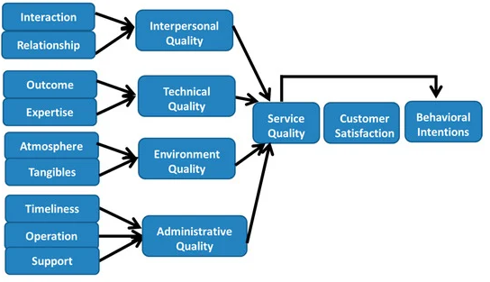
Fig:1 Servqual model Source: (Ko and Chou, 2020)

Service recovery Paradox theory
Service recovery Paradox theory provides businesses with broader customer understanding regarding their choices and preferences. Restaurant management, based on clients' visits, obtains their feedback to identify any loopholes that might create negative impressions related to services delivered across restaurants (Tontini et al.,2022). Customer reviews based on a polling system would provide an estimation to operational managers about customers' respective complaints and their services-related queries. By recording customers' complaints, satisfactory services are offered during revisits of clients. The majority of restaurants utilize polling systems and comment cards to identify customers' respective reviews as per services offered (Sun et al.,2022).
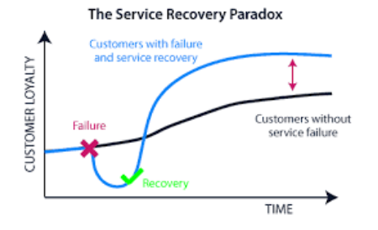
Fig:2 Service Recovery Paradox Model Source: (Coppell, 2020)
With the service recovery paradox, customers can identify improvements initiated by hotel staff. Based on enhancement in services, clients would rate restaurants to be more satisfactory in terms of service deliverance and client dealing (Xu., 2021). Additionally, high-end restaurants utilize a questionnaire approach to collect clients' responses with the aim of identifying how effectively they have been able to respond to clients' queries. High-end restaurants in London have been recognized for providing quality and satisfactory services based on customer visits (Biswas and Verma., 2023).
Raising the customer satisfaction ratio has become convenient for high-end Pakistani restaurants in London based on the service recovery paradox approach consumed by the majority of these restaurants. The service recovery paradox model has been significant in predicting consumer behaviour and demonstrates valuable insights by mentioning clients' choices (Anwar and Ozuem., 2022). With constructive feedback, hotel staff would be able to transform their operational strategies while serving guests.

Consumer behavior theory
In 1970, Krugman and Hartley proposed the concept of consumer behaviour theory to understand the purchasing behaviour of customers and factors that directly impact the psychological behaviours of customers when selecting a specific product or availing of a service (Hinterstein., 2020). According to consumer behaviour theory, businesses utilize certain techniques, models, and instruments to identify purchasing behaviours and buying intentions of customers based on their purchasing choices. Marketers predict buyers' knowledge pertaining to products/services offered as it provides an in-depth understanding of why your customers purchase a particular product or avail of a specific service (Hajli et al., 2020). Businesses predict purchasing knowledge based on customers' buying behaviour. Consumer behaviour theory relates purchase intentions by understanding customers' psyches. Targeting the right customers at the right time assists businesses in expanding their products/services and allows companies to create sustainable reputations in diversified markets (Singh et al., 2022).
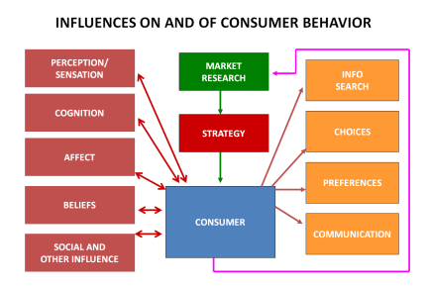
Fig:3 Consumer Behaviour Model Source: (Consumerpsychologist.com, 2020)
Restaurant businesses have been searching to identify customers' choices based on their product-related usage. Order booking, selection of food items from the restaurant’s menu, etc., describe what your customers prefer to purchase (Mahawar et al., 2022). Consumer behaviour models allow operational managers to predict customers' purchasing knowledge as they assess managers to target the right audience with specific products/services. Consumer behaviour theory enables marketers to construct customers' persona based on their attitudes and behaviours (Chou et al.,2020). The success ratio for restaurant businesses is highly reliant on a customer-centric approach, as product placement based on buying behaviour empowers marketers to retain consumers for a long duration.
Behaviour analysis is a significant component of consumer behaviour, allowing marketers to identify what customers want based on customers' information. Multi-national corporations have been relying on big data techniques to obtain customers' past buying behaviours that assist marketing managers in predicting future sales trends and product growth ratios (Morgan et al., 2022). Consumer behaviour analysis nowadays has its significance while competing in a diversified environment. Gaining customers and retaining them with business has become a challenging phase due to the increasing ratio of competitors and substitute products (Naini et al., 2022). An increasing proportion of restaurants and hotels globally has raised the ratio of choices for audiences to select restaurants of their specific choice. The trend of Pakistani food culture promoted across various regions of London has raised cuisine selection for the audience.
Social and psychological behaviour are relevant factors associated with the consumer behaviour model as marketers are able to determine product experience and respective choices for the audience (Wibowo et al., 2020). Additionally, consumer behaviour theory is related to the physiological needs of consumers for whom fulfilling basic necessities, i.e. hunger, etc., has been an essential component describing their physical needs (Tanrikulu., 2021). Food restaurants provide quality and tasty cuisines to accommodate the physiological needs of consumers. By offering cultural food dishes, customers' appetites are fulfilled based on their respective orders.
Local food restaurants that offer Pakistani cultural food have market growth opportunities by predicting consumers' choices based on their particular visits. Maximizing the customer satisfaction ratio and retaining loyal consumers would enable restaurants to sustain themselves while competing with other European restaurants that offer dishes preferred by Europeans (Rahim et al.,2023). Additionally, the consumer behaviour model allows restaurant managers to maintain a sustainable pricing model that would be adequate to gain customers' trust. Based on the affordability rate of consumers, the price of hoteling services and food dishes would assist consumers in menu selection and enable them to order food dishes that they are likely to consume (Kolhe., 2023).

Theory of buyer behaviour
In 1969, John Howard and Jagdish Sheth proposed a theory of buyer behaviour that elaborates on empirical phenomena about the purchase intentions of customers (Parvatiyar., 2021). According to this theory, the buying behaviour of consumers depends on their rational choices regarding product selection. Consumer cognitive behaviour assists in the selection of their product choices. Initially, product selection by a consumer might be due to their random behaviour; however, with time, random product selection transforms into systematic buying behaviour (Rydell and Kucera., 2021). Experience gained based on product usage enables buyers to make a systematic selection of goods.
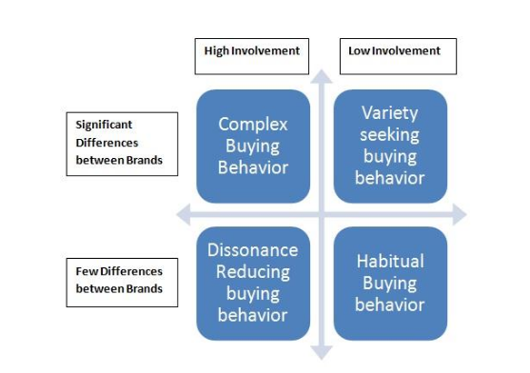
Fig:4 Buyer Behaviour Model Source: (Clootrack.com, 2023)
Entrepreneurial restaurant businesses across London that offer Asian cultural food dishes, especially Pakistani food cuisines, are in search of a sustainable market reputation and effective response rate from audiences to grow in a diversified market (Chatterjee., 2023). Buyer behaviour theory has significance for restaurant managers in terms of predicting cuisines adored by local communities living across London (Ogundijo et al., 2021). The majority of buyers' behaviours are repetitive, allowing marketers to understand their specific choices. Based on revisits performed by customers across local restaurants in the UK, marketers are able to construct purchasing cycles that describe which product has a higher growth ratio and would assist managers in generating expected sales margins. However, one of the challenging phases for marketers and sales personnel across the restaurant industry is that food orders placed by customers are frequent for people who visit hotels and restaurants (Roy., 2022).
With an increased ratio of local cultural restaurants in London, it has become a significant challenge for entrepreneurial food businesses to predict consumers' choices due to the increasing rate of substitute products (Najib et al., 2020). However, the distribution of food cuisines with their placement across food menus in restaurants has been classified based on product categories that assist consumers with a selection of food dishes they taste mostly (Putra et al., 2023). To capture higher market share and to maintain a sustainable reputation across the restaurant industry requires choice identification that would have been convenient for marketers while placing cuisines within the food menu.
Food marketers need to analyze customers' food selection based on their initial visit to a restaurant, which would assist them in capturing their cuisine choices during their revisits. Based on customers' feedback, their food experiences that describe their product-related preferences would be collected (Ballco and Gracia., 2022). Selection of food cuisine might be rational for different customers or would be irrational as a majority of people randomly or instantly select food dishes based on cuisine options available within the food menu. However, irrational choices for food selection might impose complications for marketers when predicting sales rates for each food dish (Salins and Aithal.,2022).
On many occasions, during get-togethers, cultural events, and social gatherings, people adore selecting food items that are preferred by their associates. It would be highly convenient for marketers and restaurant managers to predict the dishes to be ordered (Brewer and Sebby., 2021). Additionally, past experience related to cuisine selection by clients would assist hotel managers in identifying which dish within the food menu would be selected by customers on their revisit (Cai et al., 2021). Collecting customers' food reviews and service experience assists hotel staff in capturing the extent of customer satisfaction. Additionally, recording complaints/queries would allow managers to determine areas of improvement within services. With customers' food choices, restaurants predict consumer behaviour, allowing them to generate expected revenue margins (Roy et al., 2022). Customer loyalty has been highly dependent on how well marketers have identified consumer preferences and how likely they have been able to deliver customer knowledge to restaurant staff.

Chapter:3 Research methodology

Introduction
This section of the dissertation will provide readers with in-depth knowledge pertaining to data collection techniques and research methods considered while investigating how high-end Pakistani restaurants have been able to adopt sustainable consumer satisfaction strategies while operating across local regions of London. Readers will get to know the researcher's approach consumed during the investigation research objectives of the study. The research paradigm within the study creates a framework assessing the researcher to develop a sustainable research strategy to meet the research aim. By creating a well-defined plan for investigating the research topic, expected outcomes can be obtained during the course of research. Based on the research approach and strategy, the dissertation would define the direction used by the investigator to accomplish the goals of the study. Research methodology provides overall researcher techniques about how data has been included and what techniques have been included to gain meaningful knowledge within an investigation.

Research paradigm
The research paradigm sets a framework while examining research questions. It demonstrates research philosophies consumed within studies, research approaches and data collection techniques. The research paradigm is comprised of various categories, including descriptive, exploratory, etc. Apart from methodology, the research paradigm structure consists of ontology and epistemology. Ontology consists of the nature of universal reality (Kaushik and Walsh., 2019). Identifying logical and meaningful ideas behind a reality demonstrates ontology. Ontology is a philosophical approach that investigates the existence of entities and the interrelation between them. By determining the existence of the physical environment, researchers would be able to acquire meaningful knowledge pertaining to the existence of objects associated with their investigation (Khatri., 2020). By investigating logical truth, a researcher would logically interpret reality within their investigation. Additionally, the ontological approach prescribes that the real world exists and is not dependent on the human experience. However, relativist ontology demonstrates that reality has been constructed within the human mind as no reality exists in actuality. Differences in opinions based on various categories of ontology enable researchers to investigate true rationale and meaningful logic while examining universal truths (Muzari et al.,2022).
Epistemology, however, consists of each method associated with acquiring knowledge. With valid information, the researcher would be able to draw logical conclusions during the course of an investigation. Objectivist epistemology demonstrates that reality exists as a researcher based on reliability and validity and outlines factual knowledge during an investigation (Al-Ababneh., 2020). The concept of epistemology constructs the relationship between the mind and reality. By researching meaningful information, researchers include logical knowledge within research studies.
The research paradigm provides a model, method, strategy, pattern, and procedure for investigating research objectives. Below is a research onion demonstrating the paradigm used by researchers.
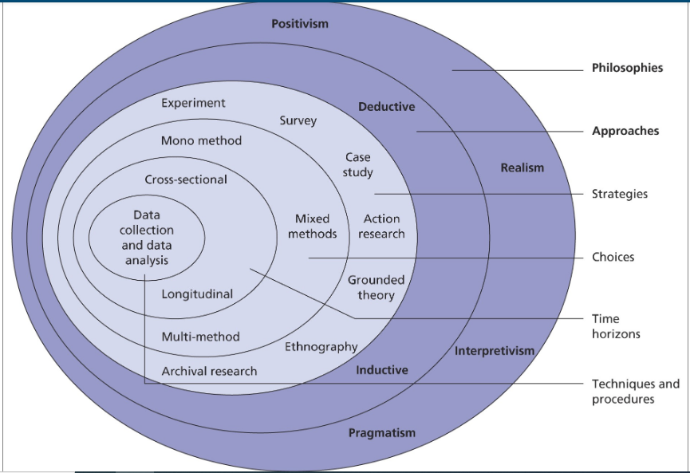
Fig:5 Research Onion Source: (15 Writers, 2019)

Research approach
The research approach defines the research direction considered within the investigation while researching goals to accomplish. Selecting a research approach depends on the researcher's criteria to perform an investigation. The research approach consists of inductive, deductive, etc. (Gupta et al.,2022).

Inductive
Inductive reasoning defines studies conducted from scratch point as researchers investigate objectives from the initial stage to interpret an in-depth understanding of the rationale behind the study. Studies conducted during the initial phase describe inductive reasoning (Walter and Ophir., 2019). Based on a research topic, the researcher’s approach is to examine by involving the external environment. To gain logical facts and meaningful information, researchers investigate the research problem from the beginning. No theoretical support and past knowledge has been used while investigating based on inductive reasoning (Chandra et al., 2019). Theories are established as the end result of the study to fill the research gap. While examining through an inductive approach, the researcher examines the origin of information to include valid arguments and logical knowledge for readers.

Deductive
Within the deductive approach, the researcher considers past theoretical frameworks and related theories to establish hypotheses statements while investigating the extent of the relationship between variables/factors (Pandey., 2019). By constructing a hypothesis statement, the researcher gets a particular direction pertaining to what to examine during the course of the study. To validate past theories, the researcher examines hypothesis statements by using reliable procedures to analyze the information collected. Hypothesis statements are accepted or rejected based on the findings of the study.

Justification of deductive approach
For the current investigation, the deductive approach has been selected as the researcher has based the study on a theoretical model by considering how past theory objectives were structured. Based on consumer and buyer behaviour theory, factors that customers perceive while visiting restaurants. have been outlined. Hence, with theoretical formation, the researcher organized the study pattern.

Research strategy

Interpretivism
Interpretivism school of thought indicates human perceptions and knowledge gained by participants while including them during the course of the investigation (Junjie and Yingxin., 2022). By involving participants, the researcher would be able to introduce meaningful interpretations based on research questions established within the study. By involving respondents, various concepts pertaining to research investigation would be collected, through which researchers would be able to draw meaningful conclusions within dissertations. By randomly selecting participants, various forms of knowledge are collected that assist the researcher in understanding the concepts of the study in a detailed manner (Scauso., 2020). People have different perspectives, due to which differences in opinions are collected, resulting in various kinds of primary knowledge that can be used in studies that assist researchers in investigating objectives.
The researcher includes human subjects related to the topic under investigation as a selection of an appropriate population enables the investigator to extract relevant information about the subject matter. By including a small proportion of participants from the whole population, a researcher would be able to attain appropriate information (Curry., 2020). Results collected from a small proportion of the population would, however, be implemented on the whole population. Based on sampling techniques, the researcher selects participants within the studies. With the random sampling technique, different participants related to the investigation have prior knowledge and understanding pertaining to questions constructed by an investigator (Van., 2020). Most researchers include a convenience sampling technique to include participants who can conveniently be searched and who would suitably be included in the investigation.

Positivism
Positivist schools of thought demonstrate scientific inquiry conducted within experimental labs based on observations. With scientific investigations, researchers are able to gain authentic secondary information (Park et al., 2020). Data collected within controlled studies describe the positivism approach, indicating factual knowledge included within an investigation. Additionally, secondary data collected from authentic secondary sources, i.e., Google Scholar, government websites, etc., defines the positivist approach (Vitulyova et al.,2020). Secondary data on publically available authentic secondary sources is used by researchers to maintain reliability within studies. While collecting secondary data sets, utilizing published data would be appropriate for the researcher to accomplish valid outcomes.

Justification of interpretivism strategy
The research strategy considered in a dissertation is interpretivism, which demonstrates how the subjects of the study have responded to their experience. The rationale for considering interpretivism is to analyze customers' visiting experience in various Pakistani high-end restaurants. Based on their reviews, the researcher would conduct an analysis of the investigation.

Research Methodology
Research methodology outlines the overall research methodology considered by the researcher during the investigation while examining the research problem. The selection of research methodology provides readers with an overview of how data would be included in an investigation (Mishra and Alok., 2022). Additionally, data collection techniques and research approaches are described based on the selected methodology.

Qualitative methodology
The qualitative research design consists of using words, concepts, theories, etc., to include detailed information pertaining to the investigation. Qualitative studies are exploratory in nature, as with descriptive phenomena, readers are provided with in-depth knowledge based on defined facts (Tesar., 2021). Primary data within qualitative studies are collected by using an interview approach, whereas secondary data is extracted from authentic secondary sources. To gain detailed knowledge, researchers include participants in studies to understand detailed perspectives relevant to the investigation (Roller., 2019). By conducting face-to-face interviews, the researcher collects primary knowledge to gain participants' understanding of the topic. Interviews are semi-structured or open-ended, depending on the nature of the study and the researcher’s individual strategy to collect primary information from participants. With thematic analysis, researchers construct themes and codes based on primary information extracted from participants (Lopez et al., 2021). To extract secondary information within qualitative studies, researchers utilize secondary sources to gain meaningful knowledge within studies. By describing concepts, theories, etc., investigators establish efficient and reliable results.

Quantitative methodology
Within quantitative studies, researchers emphasize collecting numerical facts by quantifying results. Quantitative interpretation is performed within an investigation by using numbers, figures, statistical data, etc. Researchers avoid including detailed analysis; however, they emphasize logical interpretation based on facts (Ahmad et al., 2019). With graphical representation, statistical illustration, etc., readers will get to know about factual results collected within studies. Within quantitative studies, primary data is collected by involving participants within the study. With the survey questionnaire approach, the research collect closed-ended responses from involved respondents (Soldati et al., 2020).
To collect survey data by means of a questionnaire approach, the researcher utilizes both face-to-face survey and online methods for the convenience of participants and investigators. Statistical software is used to analyze primary data sets to examine the reliability and extent of the relationship between variables (Al-Ababneh., 2020). Most commonly, SPSS software is used within quantitative studies for interpreting primary data sets collected from participants through a survey questionnaire approach. Statistical analysis is performed by means of various tests used within SPSS, including reliability, frequency, descriptive statistics, regression, correlation, t-test, etc. (Almquist et al., 2020). By demonstrating table formation of results collected from SPSS software, the investigator includes meaningful interpretation within studies.

Justification of qualitative and quantitative methodology
For the current investigation, the researcher considers qualitative and quantitative methodology. The rationale for selecting both methodologies is to conduct an in-depth secondary analysis by considering customer reviews available on the official restaurant's website. For qualitative analysis, reviews would be evaluated in detail, whereas to identify the total visiting rate for customers, a quantitative methodology has been considered.

Data collection
For this investigation, the researcher has primarily emphasised the secondary data collection approach by considering customers' reviews as per their experience in Pakistani high-end restaurants; their reviews available on restaurants' websites are included in the investigation. However, the researcher avoids performing primary data collection techniques as, irrespective of collecting first-hand responses; the investigator prefers to extract customer reviews.

Sampling method
The sampling method assists the researcher in selecting participants during the course of the investigation. The selection of the sampling method depends on the nature of the topic and the researcher's strategy to gain quality outcomes (Stratton., 2021). Various categories of sampling are used within studies; most commonly, the convenience random sampling technique is used. The researcher select participants who have primary understanding pertaining to the research problem and who would be conveniently available and accessed by the researcher.

Justification of sampling technique
For this investigation, the researcher considered a convenience random sampling technique through which the researcher selected customer reviews by randomly analyzing customers' reviews on the official websites of selected restaurants.

Ethical consideration
Maintaining ethical implications within research studies is the primary responsibility of the researcher. Securing participants' personal information and responses is an ethical aspect of investigation (Husband., 2020). While including respondents, their consent is mandatory, for an ethical consent form is provided to collect their approval before involving them in research. Those participants who provide their consent by authorizing their involvement based on the ethical consent form are included in the studies. An ethical consent form is legal proof that permits the investigator to collect primary information from participants (Xu et al.,2020). Additionally, respondents who want to withdraw their information and responses from the investigation are provided authorization to withdraw their responses from studies anytime they feel uncomfortable. However, it is the investigator's adequate duty to describe to participants the rationale behind the investigation and the area of research where participants' responses are to be included within the investigation (Millum and Bromwich., 2021).
Additionally, research investigators ensure participants that their information and responses will be discarded from the investigation after accomplishing the research goals. Moreover, the researcher assures that their personal information will be preserved and remain confidential throughout the study. To preserve responses collected from participants, researchers utilize USB devices, laptops, etc., to store participants' information (Eerola et al., 2021). Digital devices encrypted password protection researchers preserve participants' responses.

Justification of ethical implications
For this investigation, the researcher has performed ethical implications by considering the names of the customers confidential; however, their responses based on their experience are included in the study. By preserving customers' personal information, their responses are included for conducting secondary analysis.

Access issues
Participants who would be included in the study accessing their information are not authorized by the investigator to ensure their safety and security. To avoid external interference or to avoid data theft, access to personal information is avoided during this investigation.

Research limitations
The current investigation included secondary analysis by customer reviews; however, the primary analysis method has been avoided by an investigator.

Time horizon
Due to a shortage of time, limited customer reviews are included in the investigation; however, with more time, more reviews and further knowledge would be included in the studies.

Chapter:4 Findings and Discussion

Qualitative findings
The current investigation excludes secondary research articles for examining and evaluating knowledge pertaining to how customer satisfaction has been maintained by High-end Pakistani restaurants in London. The rationale for not using secondary research articles is due to the non-availability of relevant journal articles on publicly available secondary sources. However, the researcher has emphasized conducting customer reviews to inspect how Pakistani restaurants are offering quality food and sustainable hoteling services to visitors.

Taste of Peshawar

Customer service



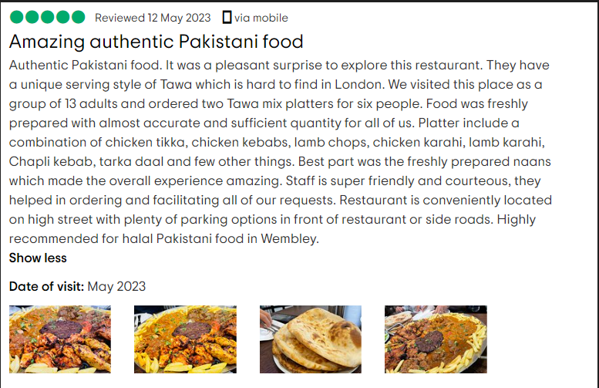

Food quality
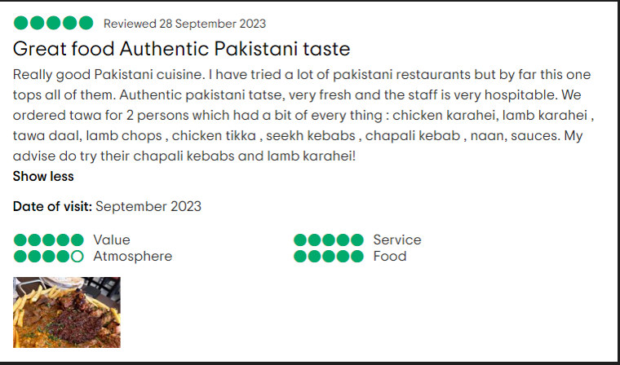
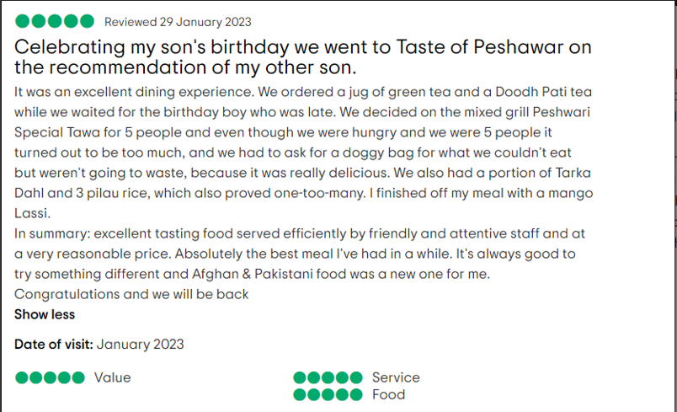
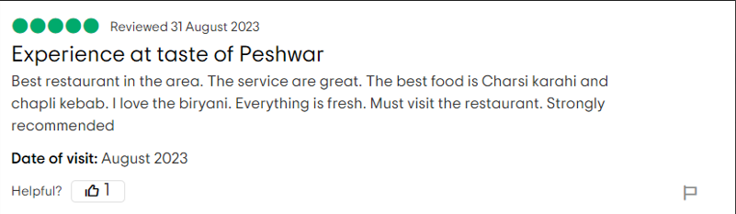

Karachi cuisine

Customer service

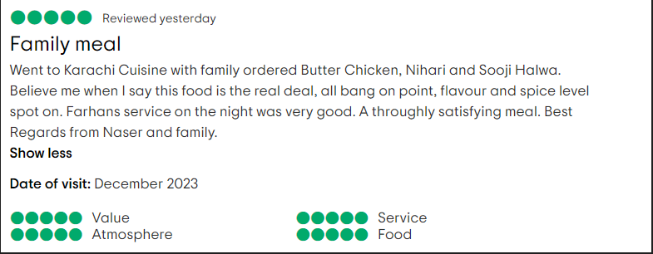
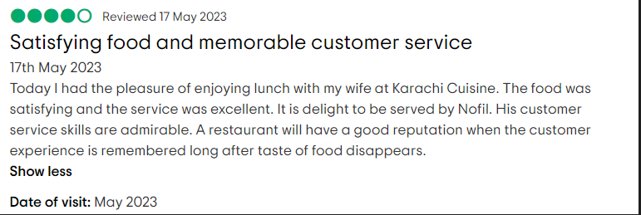
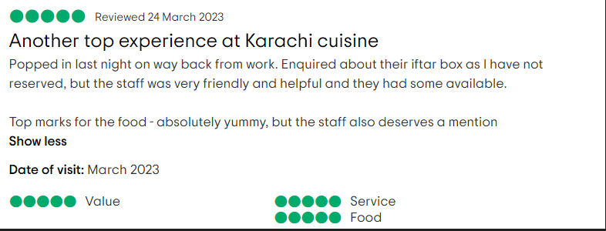

Food quality
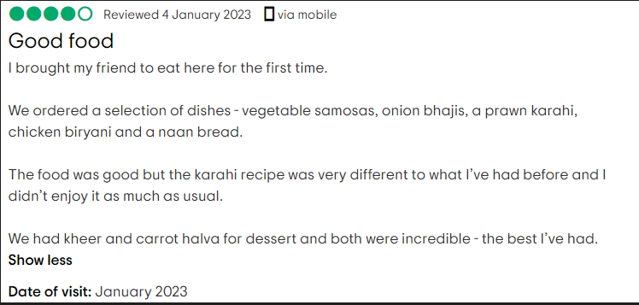

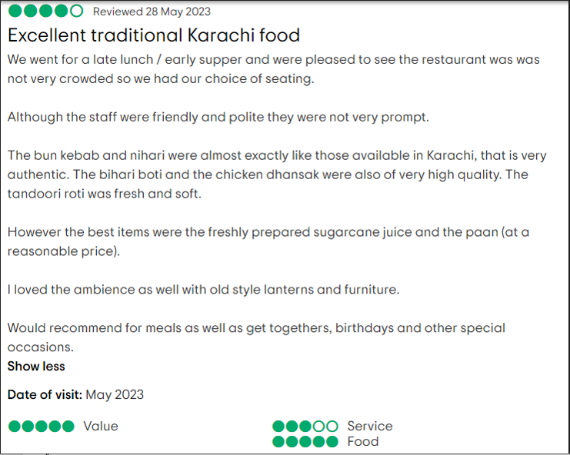


Namaaste highgate

Customer service
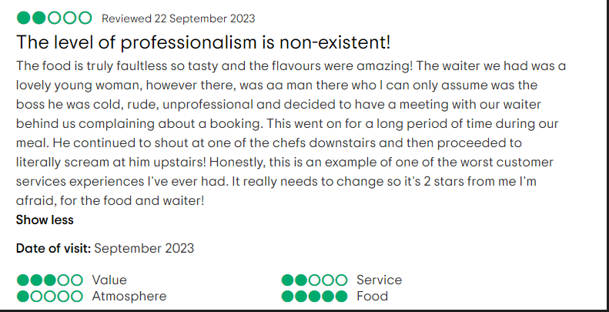
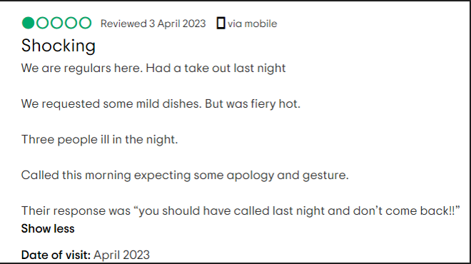


Food quality
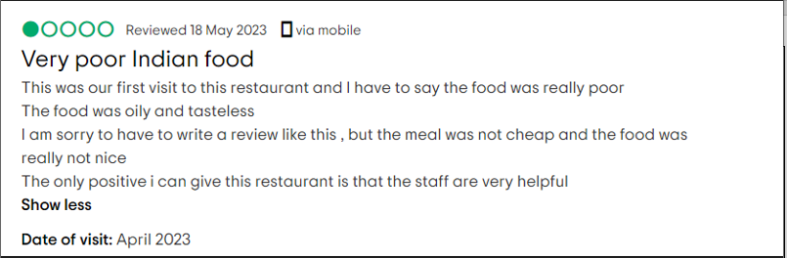



Spice Village Tooting

Customer service
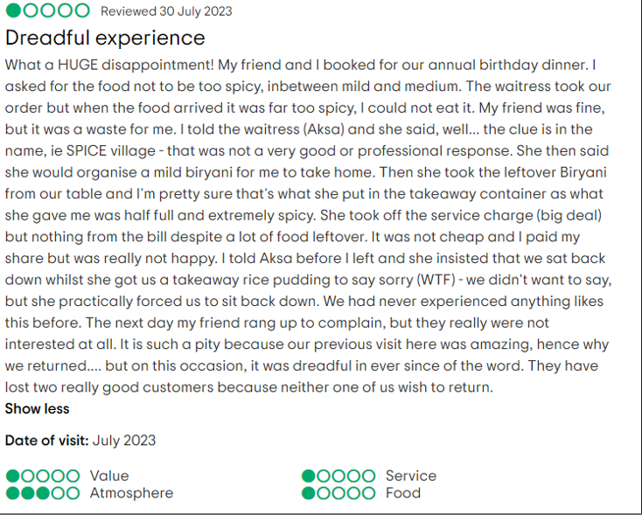
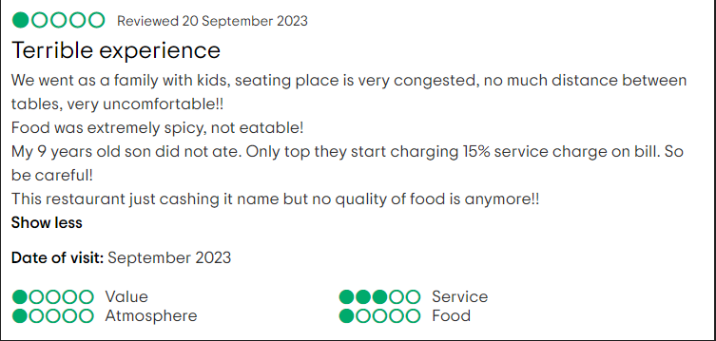


Food quality
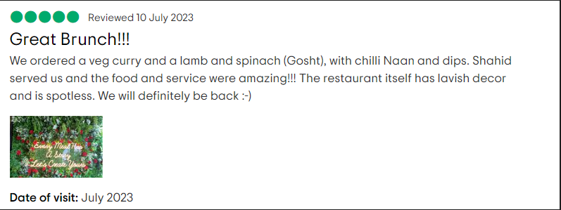
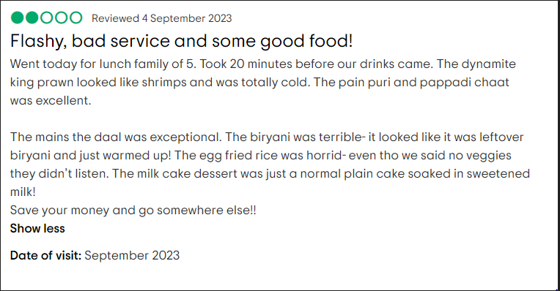
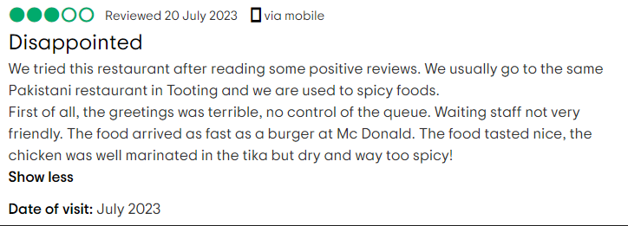

Zayna

Customer service

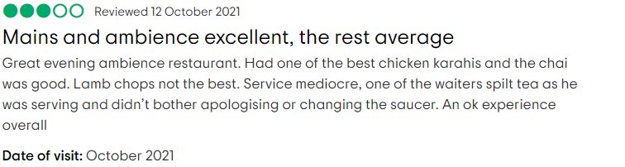

Food quality


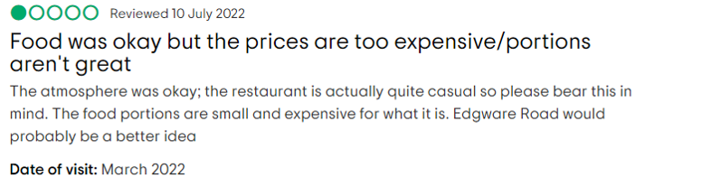

Lahore Village

Customer service


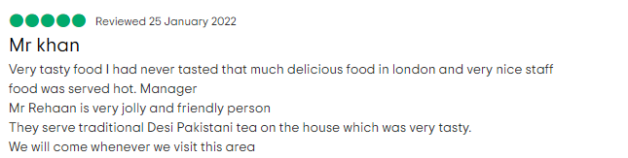

Food quality
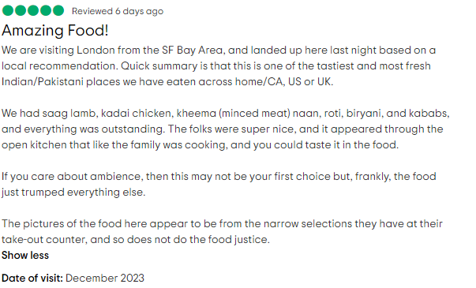

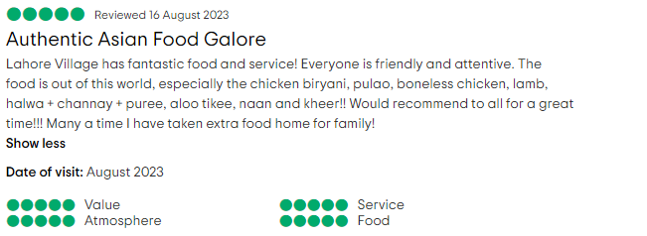

Lahore Kebab House

Customer service

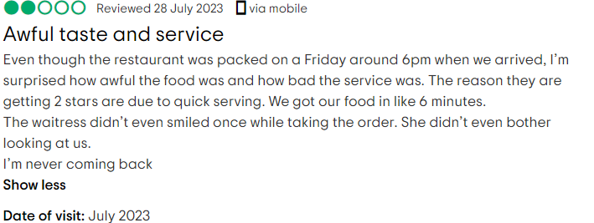
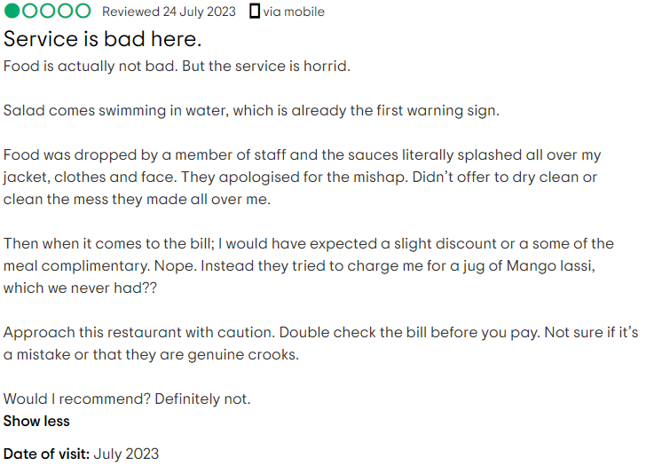

Food quality
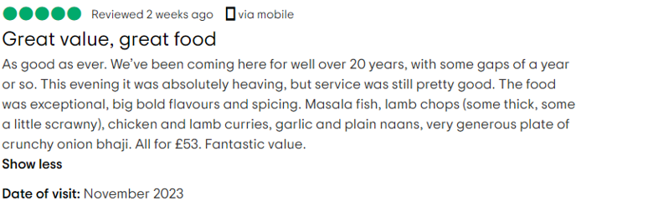
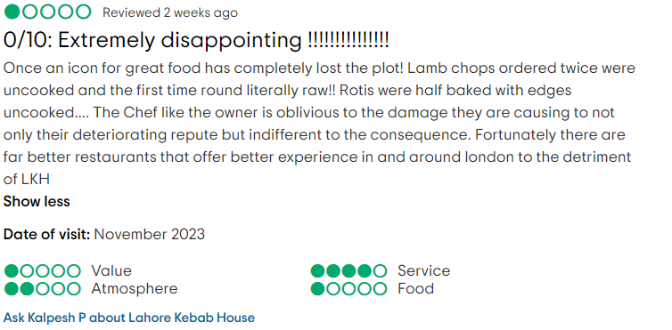
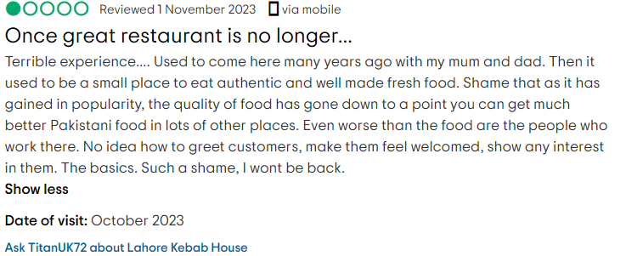

Dar's

Customer service




Food quality

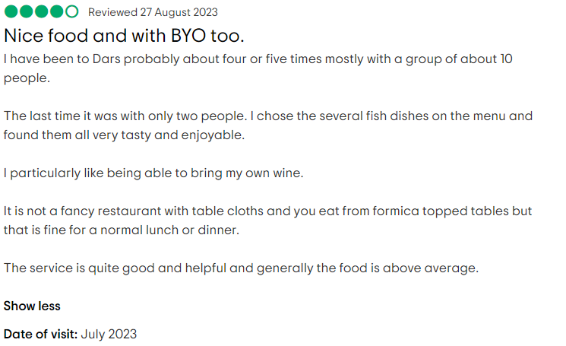


Al Kareem

Customer service



Food quality
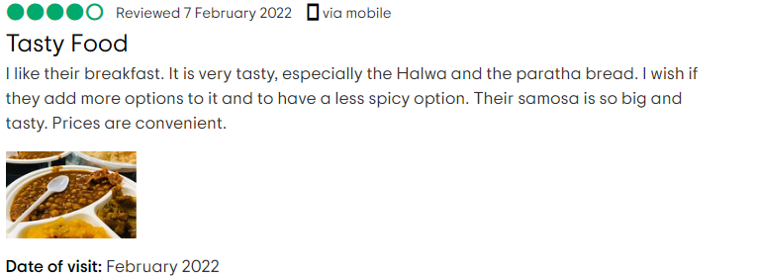
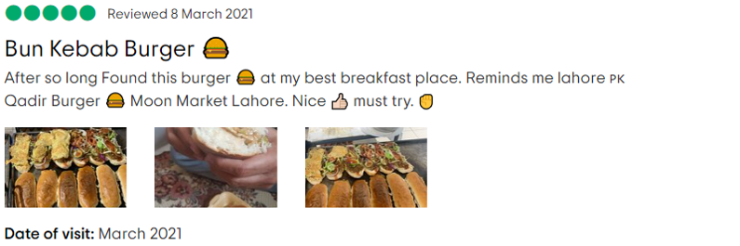
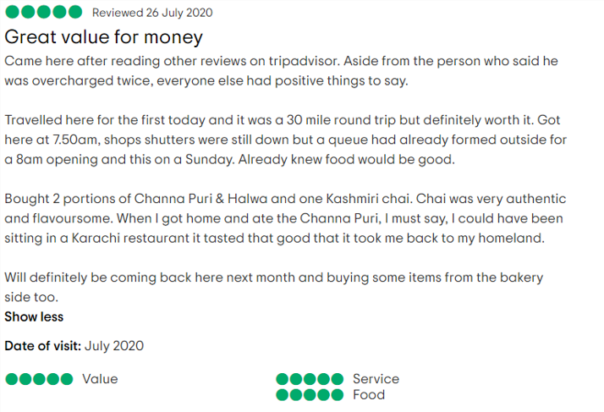

Lahori Nihari

Customer service
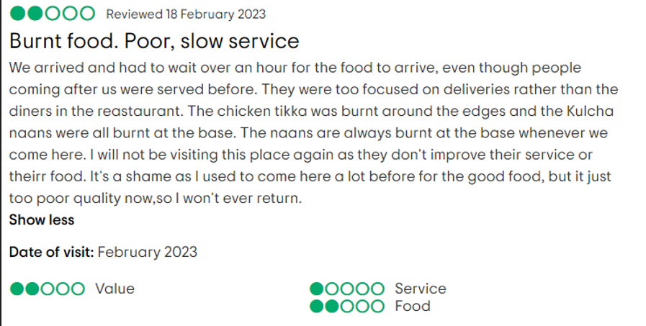

Food quality


Qualitative Discussion
Based on customer reviews, each Pakistani restaurant has been categorized for its rating for customer service and food quality. For each restaurant, below is a discussion pertaining to customers' experience as per their visits.

Taste of Peshawar

Customer service

Customer:1
One of the customers mentioned that on their first visit to Taste of Peshawar with his family members, including mother & son, they experienced quality services from the staff. Mentioning the name of the staff member (Taimoor) who was a kind and polite person timely served ordered food. Another staff member (Jihad) was quite attentive and catered to food needs as per the placed order. The customer elaborated that hospitality service from the staff was a prior reason for rating a 5-star review for the services.

Customer:2
Another customer presented his review based on their experience and rated 1-star for service as mentioned that the staff was cooperative and generous.

Customer:3
A review collected by a customer who visited Taste of Peshawar elaborated that the restaurant staff was cooperative, had a unique serving style, and served the food dishes ordered. The staff was courteous and very friendly in nature with professional behaviour. Waiters booked our order while facilitating all of the requests mentioned. Food was served on time; additional services were provided by waiters with a supportive hotel manager. Based on service quality, I have rated 5 stars.

Food quality

Customer:4
A customer mentioned that the food quality was good and that trying Pakistani cuisine in Taste of Peshawar was an excellent experience. Taste was fresh for ordered food i.e. chicken karahi, lamb karahi, tawa daal etc. Based on the restaurant's visit, the customer rated 5 stars for both the food quality delivered and the staff service offered. The internal atmosphere was rated 4 stars, with value-added services to 5 stars. Service experience in a quality environment was perfect due to the cooperative staff members. The customer discussed that the taste of food items resembled the cultural taste of ordered food dishes, i.e. chapli kebab, naan, chicken tikka, etc.

Customer:5
A customer shared his experience when he visited with his family members to celebrate his son's birthday. Food items ordered included Peshawari special tawa, Tarka Dahl, Pilou rice, etc. Based on customer reviews, it is evident that Taste of Peshawar restaurant offers excellent taste food items in an affordable price range. Having the best meal was a memorable experience. Based on his experience, he rated 5-star for food quality and 5-star for customer service.

Customer:6
The customer rated 5 stars based on his review pertaining to his food experience in Taste of Peshawar. Food items tried include charsi karahi, chapli kebab, biryani, etc. Excellent customers referred and recommended others to visit the restaurant to taste quality Pakistani cultural food items.

Analysis of Taste of Peshawar
Based on reviews collected from customers who have visited Taste of Peshawar restaurant, it is evident that the customer service and food quality offered within the restaurant were excellent. Each customer provided a good review based on their experience that outlines how, with supportive staff, a quality amount of services are presented to clients on their visits. Most of the customers included in the reviews rated 4-5 stars, describing the extent of services offered by the restaurant. Taste of Peshawar can be described as a ranked restaurant that provides quality services to guests during their visit. Reviews collected from customers indicate that staff was quite cooperative and well-trained and skilled in providing customer services. Additionally, other staff, including chefs, hotel managers, etc., are providing their services as per their capabilities.

Karachi cuisine
The reviews below are collected from customers based on their visit to Karachi cuisine. Reviews are distributed based on food quality and customer service offered in a restaurant.

Customer service

Customer 1
A customer mentioned that he visited a Karachi cuisine restaurant with his family, where he experienced Pakistani food dishes, including Nihari, Sooji Halwa, Butter Chicken, etc. The customer outlined that spice and flavour were quite good for the food items ordered. Additionally, customer service provided by staff was satisfactory. Farhan was the waiter who served as per the customers' expectations. Based on the quality of customer services, Naser rated 5 stars while sharing service experience on behalf of his family. In addition, the internal atmosphere was pleasant, with impressive interior décor.

Customer 2
A customer mentioned his experience with his wife at Karachi cuisine, which was excellent. Nofil was the waiter who provided on-time ordered food items to guests. With his customer handling capability, customers rated highly on customer services. With a sustainable market reputation created based on qualified staff, customers rated 4 stars based on their memorable experience while served by experienced restaurant employees.

Customer 3
Another customer shared their experience, mentioning that the staff working in Karachi cuisine was quite friendly and assisted customers on their visits. Customer rated 5-star on their services and for value-based environment.

Food quality

Customer 1
Another customer shared his experience with his friend who ordered Pakistani food dishes, including vegetable samosas, onion bhajis, prawn karahi, chicken biryani, etc. Food dishes were incredible mentioned by a customer who rated 4-star for food services offered in the restaurant.

Customer 2
Customers mentioned that they experienced excellent traditional food dishes as per cultural taste. Food dishes ordered, including Bihari boti, tandoori roti, etc., were fresh and tasty. Customers rated 5-star on food dishes tasted in the restaurant, with value-added services rated 5-star.

Customer 3
Another customer reviewed the food dishes tasted in Karachi cuisine restaurant. He rated 5-star with a 10/10 rating on food items being served by hotel staff.

Analysis of Karachi Cuisine
Based on customers' responses, it is evident that Karachi cuisine gained a sustainable market reputation by offering quality food dishes and customer services with experience staff members. By presenting traditional food dishes with cultural tastes, customers prefer to visit restaurants with their families and friends.

Namaaste highgate
Below are reviews of customers as per their visits to Namaste Highgate, as distribution based on food quality and customer service has been performed.

Customer service

Customer 1
Based on my visit to Namaste Highgate, customer service representatives were kind and cooperative as they served good quality food with cultural flavour. The waiter who served us was a young lady who was kind and treated us in a positive way. She was supportive and provided us with ordered food items in a timely manner. However, there was a manager who was so rude and unprofessional and complained about the booking. His unkind behaviour was a negative aspect that we noticed on our visit. His negative behaviour impacted our visiting experience as it was hectic while eating due to unexpected behaviour. He was yelling at each waiter, describing his rude attitude. I would say that the service experience was bad for me. I will provide 2 stars based on my worst experience; however, the waiters were supportive, due to whom I am rating 2 stars. However, the food was delicious, and I would rate 5 stars on the food dishes that we ordered.

Customer 2
Our experience was shocking due to non-cooperative behaviour while visiting Namaste Highgate. The food dishes that we ordered were mild and were hot to be eaten. Although we are regular customers, the attitude of the restaurant's staff was highly unbearable. I would rate 1 star due to poor customer service and the behaviour of the waiters and other staff.

Customer 3
A review from another customer outlines that the food served by waiters was not good in quality and taste. I would avoid recommending any other to visit the restaurant. Due to the lack of proper service, I was not quite satisfied. I would rate it 1 star based on the customer service offered by restaurant waiters.

Food quality

Customer 1
Our visit to Namaste Highgate was to taste and experience Indian food dishes as we ordered food items with oil that were, however, not good in taste. Although the meal was expensive, the food did not taste good. However, the staff was quite helpful and supportive and provided timely services. Ordered food dishes were presented on time, which was good. However, based on the taste of the food, I would rate it 1 star as my eating experience was unpleasant.

Customer 2
Based on our visit, the ordered food dishes tasted good, and the interior decoration was pleasant and attractive. Additionally, customer service was excellent. We experienced starters, and main course, which were quite delicious, and the service provided by the restaurant staff was generous. I would rate 5 stars based on the taste of the food dishes, and I would recommend others to visit the restaurant to experience quality food dishes with supportive customer service.

Customer 3
A customer mentioned that the food items were quite tasty, and the staff members were attentive and gave outstanding service. We tasted the best curry on our visit. Additionally, while serving in a cooperative environment, it was quite a good experience, with timely service from staff members.

Analysis of Namaste Highgate
While analyzing customer responses provided by clients based on their visits to Namaste Highgate, it has been identified that service quality was not good due to the non-supportive attitude of staff members experienced by customers. Customers, based on their visits, have rated poorly to 1 and 2 stars, which indicates that customer services were not as per visitors' expectations. However, for food quality, the restaurant is rated higher comparatively from customer service. Customers rated 5 stars based on their food experience. Ordered food dishes were tasty and delicious, which would positively inspire customers. It is evident, based on customers' responses, that they would visit the restaurant because of the delicious food quality; however, customer service was not supportive.

Spice Village Tooting

Customer service

Customer 1
A customer mentioned that their experience was awful as, irrespective of ordering mildly spiced food items, the waitress provided food dishes that were too spicy, which I was not able to eat. Waitress Aksa said that as it is obvious from the name of the restaurant, we are recognized for providing spicy food items. However, from my perspective, her response was not quite professional. The waitress said that she would book mild biryani as a takeaway. Service was incredibly poor as the waitress promised to book mild biryani. However, she packed leftover biryani. The food was quite expensive, and my experience was not satisfactory. Additionally, we had to wait for an away order; this was quite a drastic experience. Although our previous visit was quite good, it was not good at this time. I would prefer not to come again as I have rated 1 star due to poor customer service experience. Additionally, I would rate 1 star based on food items I have ordered and tasted.

Customer 2
A customer mentioned that he visited with his family members as the seating arrangement was congested due to the uncomfortable sitting environment. It was not a good experience at all. Additionally, the food dishes we ordered were full of spice, which made it difficult to eat. Moreover, they were charging 15% for additional service charges. I would not recommend anyone to visit Spice Village tooting due to poor experience. I rated 3 stars on customer services with 1 star on food quality.

Customer 3
My experience as a customer was excellent as the food dishes that we ordered were good in taste and quality. My experience was outstanding, as customer service was excellent. The staff was cooperative and timely, serving food dishes as per the placed order. I have rated 5 stars based on food quality and customer service experience. I would definitely be coming back on the visit, and I would recommend others visit the restaurant to eat cultural food dishes.

Food quality

Customer 1
Being a customer of Spice Village tooting, my experience was excellent as we ordered food dishes including veg curry, spinach with goat, and lamb, including chilli naan and dips. The waiter who served us was Shahid, with quality food and supportive service from staff members. Additionally, the internal décor was lavishing as I rated 5 stars based on food quality and customer service. I would be coming back in future to experience similar cultural food dishes.

Customer 2
A customer mentioned that they visited with their family. Ordered dynamite king prawn, which was cold. As staff service was slow. However, the food dishes that we ordered, including pappadi chaat, pani puri, etc., were excellent in taste. However, daal was exceptional in taste, and the taste of biryani was not good enough. Although we clearly mentioned that we ordered with no veggies, egg fried rice did not taste good. Additionally, the milk cake dessert was a plain cake consisting of sweetened milk. I would recommend that others not visit Spice Village tooting while trying to visit somewhere else. I would rate it 2 stars based on service experience and food items served.

Customer 3
The customer mentioned that they are fond of eating spicy food dishes as we visited Spice Village tooting based on the recommendations and reviews of customers. However, the greeting from the staff was dreadful as there was no professional environment. Additionally, the waiters were not friendly, although the food arrived on time. The food dishes were good in taste as the chicken that we ordered was well-marinated with too much spice in the tikka. I would rate 3-star based on food dishes that we experienced; however, as per customer service, I would not prefer to rate the restaurant.

Analysis of spice village tooting
As per customers' reviews collected on their respective visits, above mentioned are their individual experiences and how they have rated based on their visits. While evaluating Spice Village restaurant for customer service, it can be observed that customers rated poorly to 1-star based on responses from waiters and other restaurant staff. It demonstrates non-cooperative management and non-supportive staff working. However, based on food quality, customers rated on average, 1 of the customers rated to 5-star while others rated 2,3-star. It describes that service experience and food quality served in spice village would rated as average or below average.

Zayna

Customer service

Customer 1
A customer mentioned that the internal decoration was excellent as the setting was adorable with quality interior décor. However, irrespective of the pleasant internal environment, service from the staff was poor as the restaurant staff was not cooperative at all. Due to impatience, my service experience was not good. The dishes that we ordered were expensive and were presented in lower quantities. The price was comparatively higher than other Pakistani high-end restaurants, describing awful customer service. Based on the visit and experience, I would prefer to rate a 1-star hotel.

Customer 2
My experience on the visit was pleasant as I ordered chicken karahi and chai, which tasted good. However, the lamb chops were not good in taste or quality. Response from the staff was non-supportive, as one of the waiters split tea and didn’t apologize. Based on food quality, I would prefer to rate services from Zayna restaurant at 3 stars.

Food quality

Customer 1
A customer mentioned that their food experience was excellent as they ordered lamb chops, which were tasty and delicious. Additionally, restaurant service was good as placed orders were provided in a timely manner. Although the price of the food items was high, due to the good taste, I would prefer to rate 5 stars while recommending others to visit to have a pleasant experience.

Customer 2
Customers review based on the recommendation of friends that they visited a Pakistani restaurant to experience cultural food items. The food, dishes and service were adorable. We ordered various food dishes that were good in taste and quality. Additionally, hotel staff were cooperative and supported visitors by accompanying them with pleasant services. I would prefer to come back to experience similar services and food items in future. Based on food quality, taste, and service experience, I would rate 5 stars to Zayna hotel.

Customer 3
The customer mentioned in their review that the internal atmosphere in the restaurant was quite excellent. Food dishes were served in small proportions; however, the price for each food item was quite high. I would prefer not to visit again due to the higher price margin for cultural Pakistani food dishes. I would rate 1-star based on experience.

Analysis of Zayna
The above-mentioned are responses from customers who have provided their reviews based on their experience while visiting Zayna restaurant. In contrast, a categorizing restaurant based on customer service rating mentioned in the reviews demonstrates average and below-average customer experience. However, based on food quality, customers' reviews are positive due to the delicious food dishes presented by staff. While rating as per food quality, customers rated above average, i.e. 5 stars, etc., denoting quality cultural food dishes presented in parallel to customers tastes. It is evident that Zayna offers quality food with exceptional taste; however, based on the rating, Zayna would be ranked lower as per customer services being offered by staff.

Lahore village

Service quality

Customer 1
While analyzing customers' reviews, it is evident that the food items served by hotel staff were delicious, with fantastic customer service offered by the restaurant staff. The internal environment of the restaurant was clean, pleasant and attractive. I have eaten food dishes before as customer service is excellent. I would prefer to rate 5 stars based on the food quality and customer service offered in the restaurant. Additionally, I would recommend that others visit Lahore village to experience similar cultural tastes in food dishes.

Customer 2
Customers mentioned that they regularly visit to fulfil their appetites, as with their cooperative staff, a friendly environment is provided to customers on their visits. The cultural food dishes ordered are fresh and tasty, representing home-cooked food items. I have visited here each time, and with excellent customer service experience and quality food dishes, I would rate 5 stars to Lahore village. Additionally, I would recommend that others visit the restaurant to experience quality cultural food dishes with a desi food experience.

Customer 3
A customer mentioned that their experience was excellent while trying delicious food in London. Hospitality from the staff was nice as Mr Rehan, the manager, was quite friendly and cooperative with their staff. We often visit to experience desi Pakistani chai. Based on their experience and positive gestures from the manager and staff, the customer provided 5 stars.

Food quality

Customer:1
The customer outlined in their review that Lahore Village offers tasty food dishes. They ordered saag lamb, qeema, biryani, roti, etc., as each dish was delicious. The waiters who served food dishes were nice and cooperative. Based on our visit we would prefer to give 5 stars to food quality.

Customer:2
We ordered lamb and chicken with chickpeas, which were delicious in taste and comprised of cultural Pakistani ingredients. The staff was cooperative and friendly, and the food dishes were cheaper. I would prefer to give 5 stars based on the quality of the food services offered.

Customer:3
Food dishes offered in Lahore village, i.e. chicken pulao, boneless chicken, lamb, aloo tikka, etc., were good in taste as we ordered. My food experience was excellent. I would recommend others try the cultural food dishes offered at the restaurant. I would prefer to rate 5 stars as per the taste of the food items ordered.

Analysis of Lahore village
Based on customer reviews provided on the basis of food quality and customer service, Lahore Village has been rated highly to 5 stars based on the service provided by its staff. With cooperative servants and supportive management, Lahore Village gained a sustainable reputation among their customers. Additionally, based on the food quality served within their restaurant, customers, based on their eating experience, are rated 5 stars, which depicts quality cultural food dishes consisting of Pakistani flavours, which are offered to clients on their visits.

Lahore Kebab House

Customer service

Customer 1
The customer mentioned that the food dishes ordered were tasty, with rapid response and customer service from the restaurant staff. Customer rated 5-star based on staff service provided on their visit.

Customer 2
Customers review bad service experiences due to non-cooperative staff, such as a waitress serving food orders in a harsh manner. I would prefer to give 2 stars based on the bad behaviour of restaurant waiters.

Customer 3
Based on personal experience, I would recommend not visiting Lahore Kebab House due to the non-supportive behaviour of the restaurant staff. The food items we ordered were dropped off by a waiter, and irrespective of apologizing, they didn’t bother to clean the mess. Additionally, the cashier charged a bill for Mango lassi, which we hadn’t ordered. It is highly recommended that visitors verify the bill for the ordered food dishes to avoid scams. Based on poor customer service, I would prefer to rate 1 star, which I was given based on the taste of the food items.

Food quality

Customer 1
The food items we placed on our visit were delicious, including masala fish, lamb chops, etc. Additionally, service from the staff was excellent and cooperative due to the quality taste of the food items; I would prefer to rate 5 stars.

Customer 2
Food items served in the restaurant were disappointing due to the taste of food dishes, including roti, lamb chops, etc. I would prefer not to visit again due to the uncooked food items being served twice. As per customers' reviews, food dishes were rated 1-star.

Customer 3
The customer mentioned their bad experience in a restaurant due to lower-quality food dishes served by non-cooperative staff. Non-cooperative gestures from staff demonstrate a lack of professional behaviour. I would rate 1-star based on food quality while preferring not to rate based on customer service.

Analysis of Lahore Kebab House
Based on customer service reviews provided by visitors, Lahore Kebab House is rated under average due to bad service experience from restaurant staff. Due to non-supportive behaviour from waiters and managers, Lahore Kebab House is not recommended on the basis of customer handling. Additionally, for food quality, customers rated below average on food dishes offered by waiters. Due to the below-average rating, Lahore Kebab House has not been recommended for customers.

Dar

Customer service

Customer 1
A customer mentioned in the review that the hotel service and internal restaurant atmosphere were excellent, with delicious food dishes served by the hotel staff. I would prefer to rate 5 stars as per food quality and customer service offered.

Customer 2
The customer reviewed positively by mentioning that their dining experience was outstanding due to the cooperative staff and the tasty cultural food dishes offered in the restaurant, which is why Dar restaurant is highly recommended. I would prefer to rate 5 stars based on the quality of the food and customer service experience.

Customer 3
The food service provided by the staff was excellent, as with fast customer service, and the traditional food dishes ordered were presented by waiters. Based on excellent and timely service and tasty food dishes, I would rate 5 stars.

Food quality

Customer 1
The customer mentioned that the biryani ordered was delicious, and the restaurant's staff provided excellent service. I would rate it 5 stars based on food, dishes, and quality of services.

Customer 2
A customer mentioned that the food dishes ordered were tasty with good staff service based on their experience rated above average to 4-stars for food service.

Customer 3
The customer reviewed excellent food quality while mentioning the cooperative and friendly behaviour of the restaurant's owner. Customers rated 5 stars based on food quality and customer service.

Analysis of Dar
Dar’s restaurant is highly recognized due to supportive behaviour from staff as it is evident from customer reviews that based on customer service ratings, the restaurant was given 5 stars. Additionally, based on food quality, food dishes depict Pakistani culture, due to which respondents provided 5 stars for taste as per their experience.

Al Kareem

Customer service

Customer:1
The customer, based on their visit, mentioned excellent food services with a cooperative gesture from restaurant management. Due to the good taste of the food, customers prefer to rate it 5-star.

Customer:2
A customer mentioned that the restaurant's staff was non-supportive due to their harsh behaviour with customers; however, the food dishes were excellent in taste and available in an affordable price range. In comparison, rating as per customer services, Al-Kareem was rated 1-star.

Food quality

Customer:1
The customer reviewed that food items are tasty and delicious and available in a convenient price range. The customer rated 4 stars based on the food quality offered in the restaurant.

Customer:2
A customer shared their experience, as mentioned, that the ordered food item depicts Lahore’s cultural food dishes, for which a 5-star rating is provided based on their experience.

Customer:3
Food dishes tried at the restaurant were excellent in taste, describing cultural food taste as based on the quality offered within their food dishes customer rated 5-star.

Analysis of Al Kareem
Based on customer reviews it is evident that customer services offered by staff are at average. Additionally, food dishes were excellent in taste, providing cultural food taste due to which food items are rated to 5-star rating.

Lahori Nihari

Customer service

Customer:1
Customer service offered in Lahori Nihari was not satisfactory as the food dishes ordered were not presented within time. I would rate it at 2 stars based on a bad service experience.

Food quality

Customer:1
The customer reviewed that the food dishes were good in taste, with excellent and friendly service provided by the restaurant staff, for which it is rated 5 stars.

Analysis of Lahori Nihari
Based on customer reviews, it is evident that as per customer services, the restaurant was rated below average; however, for food quality offered, customers rated it 5 stars.

Quantitative findings
Below are quantitative descriptions based on participants' responses related to their visits and experience within selected high-end Pakistani restaurants across London. Each customer review rating based on food quality and customer service has been graphically represented in the attached figures.
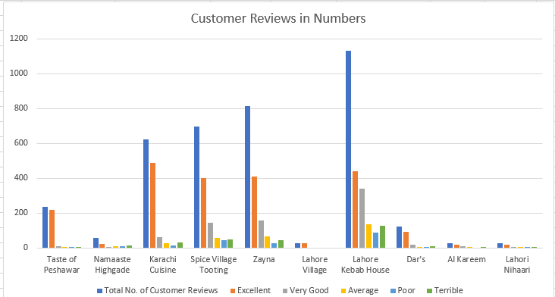
Fig:6
For each restaurant, the ratio of visitors is unequal as customers have rated based on their visit while experiencing a quality-driven approach used to maintain client satisfaction.

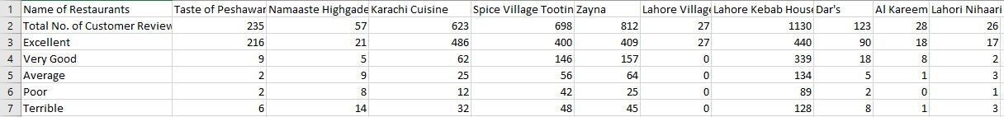
Table:1
A graphical representation of Figure 6 has been illustrated in Table 1, showing the ratio of customers as per their visits. For Taste of Peshawar, the total number of respondents who have provided their reviews is 235, of which 216 rated excellent based on food quality and service offered. Whereas 9 rated very good. However, others rated average and below average reviews for the quality of food served in restaurants.
For Namaste London, total reviews of 57 customers are considered for the investigation, from whom 21 responded with excellent services, 5 rated very good, whereas others mentioned average and below average responses. Additionally, for Karachi Cuisine, 623 participants were involved, from whom 486 responded for excellent food services, whereas 62 participants responded very well. However, others provide average or below-average responses, and reviews for other restaurants' are mentioned in the table.
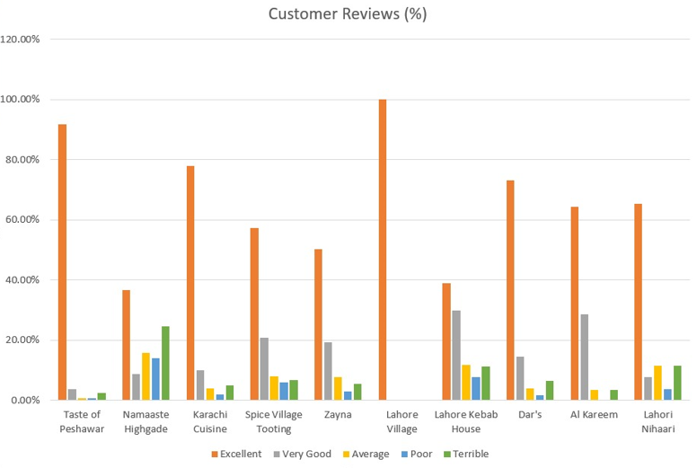
Fig:7
The above graphical figure demonstrates the percentage-wise distribution for customer responses.
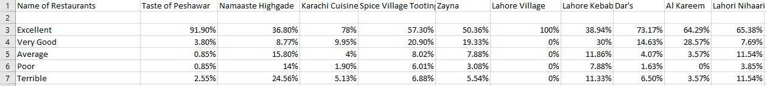
Table:2
The above-mentioned table outlines the percentage-wise distribution for each Pakistani high-end restaurant in London. For Spice Village tooting, 57.30% of respondents replied with an excellent rating, 20.90% with very good, while other participants mentioned an average and below average rating. Additionally, for Zayna, 50.36% of respondents replied excellent, 19.33% for very good and other participants rated on average and below average. Ratings for other restaurants, as per participant reviews, are mentioned in Table 2.

Quantitative discussion
As per the graphical representation in Figure, it is evident from quantitative findings that Karachi cuisine has been rated highly based on food quality and customer service experience. Secondly, Lahore Kebab House was rated excellent in terms of services and food quality by included customers. Thirdly, Zayna was reviewed as excellent in terms of customer service and cultural food dishes offered by restaurant staff.
Additionally, based on percentage distribution, Lahore village was highly rated for its excellent customer service and food quality. Secondly, Taste of Peshawar was rated highly based on the food taste offered and the quality management service from the restaurant staff. Thirdly, Karachi cuisine was rated excellent in terms of delicious cultural Pakistani food dishes offered by experienced staff who provided sustainable services to their customers.
Based on participants' rating and their respective reviews mentioned in the graphical figures, it is evident that high-end Pakistani restaurants, including Karachi cuisine, Lahore Kebab House, Zayna, Taste of Peshawar, Lahore Village, etc., are highly recommended for customer visits due to positive service response from restaurants staff with delicious cultural food items offered.

Chapter:5 Conclusion and Recommendation

Key findings
Based on qualitative and quantitative analysis performed in the investigation, restaurant service evaluation has been performed to understand the extent of services offered in Pakistani high-end restaurants. While conducting qualitative analysis, results collected based on participants' reviews mention that few high-end Pakistani restaurants are highly recognized by people who want to experience cultural Pakistani food dishes with quality staff services. Section of qualitative findings based on secondary analysis outlines that restaurants including Taste of Peshawar, Karachi cuisine, Lahore village, Dar, etc., have higher customer reputations due to on-time service from staff with quality food dishes offered by restaurant waiters.
Additionally, customers recommend these restaurants as highly appropriate for customers who want to experience cultural food dishes in London to satisfy their appetites. These restaurants are rated mostly 4-5 stars; however, other restaurants, including Namaste Highgate, Zayna, Al Kareem, etc., were rated below average due to poor and non-supportive customer service offered by staff.
A quantitative secondary discussion has been presented, with quantitative analysis performed to purposefully understand customers' responses to the top 10 famous Pakistani high-end restaurants in London. Based on quantitative findings, Karachi cuisine, Lahori Kebab House and Zayna were highly rated in terms of customer service and food quality offered by restaurant staff.
Additionally, while categorizing based on percentage distribution, Lahore village, Taste of Peshawar and Karachi cuisine are recognized as high-end Pakistani restaurants that are serving across various regions of London to customers who want to experience desi cultural food dishes. However, lower-rated restaurants, including Namaste Highgate, Dar, Al-Kareem and Lahori Nihaari, are rated below average as customers recommended not to visit these restaurants due to non-cooperative services by staff with lower quality food dishes provided to customers.

Achievement of research objectives

To critically evaluate the impact of ambience/physical aesthetics on customer satisfaction in high-end Pakistani restaurants based in London.
It is evident from participants' responses that high-end Pakistani restaurants have been fully providing impactful ambience with physical aesthetics to enhance customer satisfaction for visitors. To gain customers' interest while attracting new audiences, quality interior décor with well-furnished interior design would raise customers' interest while impacting their visit rate. Thence, it can be concluded that physical aesthetics have a positive influence on customer satisfaction.

To identify the role that food quality plays in patronage of the restaurants
Qualitative and quantitative secondary research findings outlined in the investigation outline that many Pakistani high-end restaurants are offering quality food dishes representing cultural food taste to visitors. The high-scale reputation maintained by restaurants, including Namaste Highgate, Taste of Peshawar, Karachi cuisine, Lahore village, etc., describes how well cultural food dishes are provided to visitors to enhance their experience. Hence, it can be concluded that food quality has a positive impact on customer retention rate.

To critically review the effect of customer service on customer retention/repeat patronage.
Based on customer reviews collected for the investigation and their responses, it is evident that in a few Pakistani high-end restaurants, quality customer service has been offered to visitors. With quality services, excellent behaviour, friendly gestures, positive greetings, etc., staff within restaurants satisfy visitors. Therefore, it can be concluded that customer service positively impacts on customer retention ratio.

To recommend practices that can improve customer retention in high-end Pakistani restaurants in London.
By conducting qualitative and quantitative secondary analysis, it is evident from the results that improving customer retention ratio by upgrading customer services and taste in food items served in restaurants those Pakistani restaurants can attract customers who have been poorly rated by customers based on their visits.

Areas of further research
Future researchers may emphasize addressing other regions of the UK, excluding London, to identify customer response rates for high-end Pakistani restaurants. Additionally, investigators would focus on hotels, etc., to identify how well customer services are offered to visitors.

Limitations of the study
The current investigation is limited in scope due to a shortage of time as the researcher conducted an investigation in a shorter duration. Additionally, the primary data collection technique was avoided in the investigation as direct involvement with participants was omitted by the researcher. However, future researchers might consider the primary data collection process to gain in-depth knowledge while collecting participants' experiences based on their visits.

Recommendations
Based on the findings of the study, the following are various recommendations provided to Pakistani restaurants:
- With friendly gestures and cooperative staff behaviour, a positive customer service reputation would be created.
- With improvements in food quality, tasty and delicious food dishes would be presented to customers to enhance their satisfaction rate.
- By considering on-time customer reviews, lower-graded Pakistani restaurants would be able to identify areas of improvement and customer choices related to food dishes.
- Additionally, staff behaviour would be determined based on customer reviews placed on their visits.

Chapter 06: Reflection of Professional Practice

Introduction
I am evaluating my professional practice after writing this dissertation through Gibb’s Reflective Cycle. In this dissertation, I engaged in an investigation that aims to evaluate the high-end Pakistani restaurants in London particularly. This study utilizing both qualitative and quantitative analyses and mainly involved the customer reviews to determine the food quality and services of restaurants including the impact of ambience on a customer.

Feelings
I felt excited about delving into this research study however remained confused initially but after appropriate guidance of my supervisor, I came to know the proper manner of data analysis and uncovering the insights into customer experiences. Nevertheless, I would say that I experienced mixed emotion including fear of getting rejected, confusing and anxiousness of completing the work at time. Thanks to the Grey literature that I found plenty of reviews to analyse.

Evaluation
The secondary analysis was indeed informative and discussed the significant factors such as food quality, customer service and ambience that greatly influence the satisfaction. Although secondary analysis helped me offering broad perspective, there lies the limitation on only relying on the second-hand information than getting it firsthand through interviews and surveys.

Analysis
Exploration of influence of ambience and food quality on customer satisfaction has led me to understand that creating captivating environment is most important for them. Also, there is strong relationship between the food quality and customer retention through the representation of native dishes. In that way, you are attracting a whole community and representing your country in a good sense here in London.

Conclusion
The secondary research has affirmed that holistic services in the Pakistani high-end restaurants are should include the superior ambience, excellent services and authentic food offering.

Action Plan
I aim to incorporate the primary data analysis when I will be doing PhD in Business Administration. As the study on Pakistani restaurant is scarce in the Scholarly article, there should be more research on that and how people are responding to Pakistani food. My motive is to interact with my candidates through open ended interviews to get the richer yet nuanced perspective to let the readers understand the regional variations in the customers of London.

References
15 Writers (2019). Guide to Understanding the Research Onion | 15 Writers. [online] 15 Writers. Available at: https://15writers.com/research-onion/ [Accessed 20 Nov. 2023].
Adekunle, B. and Filson, G., 2020. Understanding halal food market: Resolving asymmetric information. Food ethics, 5, pp.1-22.
Ahmad, S., Wasim, S., Irfan, S., Gogoi, S., Srivastava, A. and Farheen, Z., 2019. Qualitative v/s. quantitative research-A summarized review. population, 1(2).
Al-Ababneh, M., 2020. Linking ontology, epistemology and research methodology. Science & Philosophy, 8(1), pp.75-91.
Al-Ababneh, M., 2020. Linking ontology, epistemology and research methodology. Science & Philosophy, 8(1), pp.75-91.
Ali, M., Puah, C.H., Ayob, N. and Raza, S.A., 2020. Factors influencing tourist’s satisfaction, loyalty and word of mouth in selection of local foods in Pakistan. British Food Journal, 122(6), pp.2021-2043.
Ali, M.A., Ting, D.H., Ahmad-ur-Rahman, M., Ali, S., Shear, F. and Mazhar, M., 2021. Effect of online reviews and crowd cues on restaurant choice of customer: moderating role of gender and perceived crowding. Frontiers in Psychology, 12, p.780863.
Alimovich, F.E., Habibulloevna, K.S. and Bahodirovna, D.N., 2020. Central features of halal tourism and halal food. Academy, (3 (54)), pp.43-45.
Almquist, Y.B., Kvart, S. and Brännström, L., 2020. A practical guide to quantitative methods with SPSS.
Amidi, A., Darvishmoghaddam, E., Razmfarsa, A. and Othman, R.B., 2022. Impact of five important factors on restaurant performance and hospitality management: an empirical analysis of technological innovation. Future Technology, 1(2), pp.1-17.
Annaraud, K. and Berezina, K., 2020. Predicting satisfaction and intentions to use online food delivery: what really makes a difference?. Journal of Foodservice Business Research, 23(4), pp.305-323.
Anwar, S. and Ozuem, W., 2022. An integrated service recovery process for service failures: insights from systematic review. Qualitative Market Research: An International Journal, 25(4), pp.433-452.
Arshad, B., 2023. Food, Marriage, and Activism: Analyzing Issues of Identity Relevant to the Community of Diasporic Uyghurs in Pakistan (Doctoral dissertation).
Ballco, P. and Gracia, A., 2022. Tackling nutritional and health claims to disentangle their effects on consumer food choices and behaviour: A systematic review. Food Quality and Preference, 101, p.104634.
Batat, W. and Addis, M., 2021. Designing food experiences for well-being: a framework advancing design thinking research from a customer experience perspective. European Journal of Marketing, 55(9), pp.2392-2413.
Biswas, A. and Verma, R.K., 2023. Augmenting service quality dimensions: mediation of image in the Indian restaurant industry. Journal of Foodservice Business Research, 26(3), pp.496-527.
Brewer, P. and Sebby, A.G., 2021. The effect of online restaurant menus on consumers’ purchase intentions during the COVID-19 pandemic. International Journal of Hospitality Management, 94, p.102777.
Cai, C.H., Ding, A. and Legendre, T.S., 2021. Exploring persuasive sales techniques to improve customer acceptance of sustainable but unfamiliar menu in restaurants. International Journal of Contemporary Hospitality Management, 33(10), pp.3093-3114.
Cámara, M., Giner, R.M., González-Fandos, E., López-García, E., Mañes, J., Portillo, M.P., Rafecas, M., Domínguez, L. and Martínez, J.A., 2021. Food-based dietary guidelines around the world: A comparative analysis to update AESAN scientific committee dietary recommendations. Nutrients, 13(9), p.3131.
Chandra, Y., Shang, L., Chandra, Y. and Shang, L., 2019. Inductive coding. Qualitative research using R: A systematic approach, pp.91-106.
Chatterjee, A.K., 2023. The “decline” of London’s curry houses invented tradition, authenticity, gastromythology. Consumption Markets & Culture, pp.1-23.
Chaudhry, S., Crick, D. and Crick, J.M., 2023. I'll be there for you: coopetition and competitor-oriented activities among South Asian restaurants in two UK regional clusters. International Journal of Entrepreneurial Behavior & Research.
Chen, H., Chen, Y.J., Yang, H.T., Hsu, K.C., Zhou, M., Chen, C.S. and Chuang, P.T., 2022. Implementation of food safety management systems that comply with ISO 22000: 2018 and HACCP: A case study of a postpartum diet enterprise in Taiwan. Journal of Food Safety, 42(2), p.e12965.
Chou, S.F., Horng, J.S., Liu, C.H.S. and Lin, J.Y., 2020. Identifying the critical factors of customer behavior: An integration perspective of marketing strategy and components of attitudes. Journal of retailing and consumer services, 55, p.102113.
Clairand, J.M., Briceno-Leon, M., Escriva-Escriva, G. and Pantaleo, A.M., 2020. Review of energy efficiency technologies in the food industry: trends, barriers, and opportunities. IEEE Access, 8, pp.48015-48029.
‌Clootrack.com. (2023). What are the 4 types of customer buying behavior? - Clootrack. [online] Available at: https://www.clootrack.com/knowledge_base/types-of-consumer-behavior [Accessed 10 Nov. 2023].
Consumerpsychologist.com. (2018). Consumer Behavior. [online] Available at: https://www.consumerpsychologist.com/intro_Consumer_Behavior.html [Accessed 10 Nov. 2023].
Coppell, R. (2020). What is Service Recovery – With Examples. [online] Call Centre Helper. Available at: https://www.callcentrehelper.com/get-service-recovery-right-definition-examples-tips-152102.htm [Accessed 10 Nov. 2023].
Curry, D.S., 2020. Interpretivism and norms. Philosophical studies, 177, pp.905-930.
Danish, M.T., Amin, A. and Imam, H., 2023. Impact of Pester Power and Cultural Factor on Parental Buying Decision: Changing Food Preferences in Pakistan. International Journal of Management Research and Emerging Sciences, 13(2).
Dedeoğlu, B.B. and Boğan, E., 2021. The motivations of visiting upscale restaurants during the COVID-19 pandemic: The role of risk perception and trust in government. International Journal of Hospitality Management, 95, p.102905.
Dey, B.L., Alwi, S., Yamoah, F., Agyepong, S.A., Kizgin, H. and Sarma, M., 2019. Towards a framework for understanding ethnic consumers’ acculturation strategies in a multicultural environment: A food consumption perspective. International Marketing Review, 36(5), pp.771-804.
Eerola, T., Armitage, J., Lavan, N. and Knight, S., 2021. Online data collection in auditory perception and cognition research: Recruitment, testing, data quality and ethical considerations. Auditory Perception & Cognition, 4(3-4), pp.251-280.
El-Said, O.A., Smith, M. and Al Ghafri, W., 2021. Antecedents and outcomes of dining experience satisfaction in ethnic restaurants: The moderating role of food neophobia. Journal of Hospitality Marketing & Management, 30(7), pp.799-824.
Ferdous, M.A. and Mim, S., 2021. Factors Influencing Customers Satisfaction in Hospitality Industry: Fine Dining Restaurants.
Fuseini, A., Hadley, P. and Knowles, T., 2021. Halal food marketing: an evaluation of UK halal standards. Journal of Islamic Marketing, 12(5), pp.977-991.
Gallarza-Granizo, M.G., Ruiz-Molina, M.E. and Schlosser, C., 2020. Customer value in Quick-Service Restaurants: A cross-cultural study. International Journal of Hospitality Management, 85, p.102351.
Ghani, B., Zada, M., Memon, K.R., Ullah, R., Khattak, A., Han, H., Ariza-Montes, A. and Araya-Castillo, L., 2022. Challenges and strategies for employee retention in the hospitality industry: A review. Sustainability, 14(5), p.2885.
Graves, W.T., 2021. How Managers of Nonfranchised Restaurants Use Training to Improve Customer Satisfaction (Doctoral dissertation, Walden University).
Gupta, N., Park, H. and Phaal, R., 2022. The portfolio planning, implementing, and governing process: An inductive approach. Technological Forecasting and Social Change, 180, p.121652.
Gupta, S., 2020. Cooking Curries for change: four desi food blogs in the UK, cyberactivism, & the transnational public sphere. Diaspora Studies, 13(1), pp.72-88.
Hajli, N., Tajvidi, M., Gbadamosi, A. and Nadeem, W., 2020. Understanding market agility for new product success with big data analytics. Industrial Marketing Management, 86, pp.135-143.
Halawa, A., 2022. The Role of Immigration and Colonization in the Acculturation of Halal Food in European Countries: An Evidence-Based Systematic Review. International Journal of Social Science Research and Review, 5(9), pp.31-46.
Haleem, A. and Sufiyan, M., 2021. Defining food supply chain management—A study based on a literature survey. Journal of Industrial Integration and Management, 6(01), pp.71-91.
Helal, M.Y.I., 2022. The role of customer orientation in creating customer value in fast-food restaurants. Journal of Hospitality and Tourism Insights.
Hernández-Rojas, R.D. and Huete Alcocer, N., 2021. The role of traditional restaurants in tourist destination loyalty. Plos one, 16(6), p.e0253088.
Hiamey, S.E., Amenumey, E.K. and Mensah, I., 2021. Critical success factors for food tourism destinations: a socio‐cultural perspective. International Journal of Tourism Research, 23(2), pp.192-205.
Hinterstein, A.L., 2020. The Effects of Social Media on the Online Consumer Behaviour of University Students.
Hossain, M.S., Rahman, M.F., Uddin, M.K. and Hossain, M.K., 2022. Customer sentiment analysis and prediction of halal restaurants using machine learning approaches. Journal of Islamic Marketing, (ahead-of-print).
Husband, G., 2020. Ethical data collection and recognizing the impact of semi-structured interviews on research respondents. Education Sciences, 10(8), p.206.
Javed, S., Rashidin, M.S., Zhu, M., Xu, Z., Jian, W. and Zuo, S., 2021. Combined effects of drivers and impact of customer satisfaction on brand loyalty: The contingent effect of social trust. Sage Open, 11(1), p.21582440211003566.
Junjie, M. and Yingxin, M., 2022. The Discussions of Positivism and Interpretivism. Online Submission, 4(1), pp.10-14.
Kaushik, V. and Walsh, C.A., 2019. Pragmatism as a research paradigm and its implications for social work research. Social sciences, 8(9), p.255.
Khatri, K.K., 2020. Research paradigm: A philosophy of educational research. International Journal of English Literature and Social Sciences (IJELS), 5(5).
Ko, C.-H. and Chou, C. (2020). Apply the SERVQUAL Instrument to Measure Service Quality for the Adaptation of ICT Technologies: A Case Study of Nursing Homes in Taiwan. Healthcare, [online] 8(2), pp.108–108. doi:https://doi.org/10.3390/healthcare8020108.
Kolhe, A., 2023. Exploring the Factors Constraining the Adoption of Multi-domestic Strategy Among the Fast-Food Chains: A Case Study of Fast-Food Chains in Europe (Doctoral dissertation, Dublin, National College of Ireland).
Lane, C. and Opazo, M.P., 2023. Constructing global tastes: A comparison of two cultural intermediaries in the field of high-end cuisine. Food, Culture & Society, pp.1-27.
Le, T.H., Arcodia, C., Novais, M.A. and Kralj, A., 2022. How consumers perceive authenticity in restaurants: A study of online reviews. International Journal of Hospitality Management, 100, p.103102.
Lopez, R.P., McCarthy, E.P., Mazor, K.M., Hendricksen, M., McLennon, S., Johnson, K.S. and Mitchell, S.L., 2021. ADVANCE: Methodology of a qualitative study. Journal of the American Geriatrics Society, 69(8), pp.2132-2142.
Mahafzah, A.G., Aljawarneh, N.M., Alomari, K.A.K., Altahat, S. and Alomari, Z.S., 2020. Impact of customer relationship management on food and beverage service quality: The mediating role of employees satisfaction. Humanities & Social Sciences Reviews, 8(2), pp.222-230.
Mahawar, N., Jia, S.S., Korai, A., Wang, C., Allman-Farinelli, M., Chan, V., Raeside, R., Phongsavan, P., Redfern, J., Gibson, A.A. and Partridge, S.R., 2022. Unhealthy Food at Your Fingertips: Cross-Sectional Analysis of the Nutritional Quality of Restaurants and Takeaway Outlets on an Online Food Delivery Platform in New Zealand. Nutrients, 14(21), p.4567.
Massa, A., 2023. Cooking Multiple Homes by Revisiting Eritrean Food in London. Finding Home in Europe: Chronicles of Global Migrants, 13, p.163.
Millum, J. and Bromwich, D., 2021. Informed consent: What must be disclosed and what must be understood?. The American Journal of Bioethics, 21(5), pp.46-58.
Mishra, S.B. and Alok, S., 2022. Handbook of research methodology.
Mokhtar, S.S.M., Javeed, A. and Khan, M.Y., 2021. Halal Marketing: Concept and Strategies (UUM Press). UUM Press.
Morgan, N.A., Jayachandran, S., Hulland, J., Kumar, B., Katsikeas, C. and Somosi, A., 2022. Marketing performance assessment and accountability: Process and outcomes. International Journal of Research in Marketing, 39(2), pp.462-481.
Mroz, G., Mazhary, H. and Painter, J., 2023. What’s cooking? The normalization of meat in YouTube recipe videos consumed by South Asian British Muslims. Food, Culture & Society, pp.1-19.
Mtshokotshe, Z., 2020. Measuring customer satisfaction in restaurants in East London, South Africa (Doctoral dissertation).
Muzari, T., Shava, G.N. and Shonhiwa, S., 2022. Qualitative research paradigm, a key research design for educational researchers, processes and procedures: A theoretical overview. Indiana Journal of Humanities and Social Sciences, 3(1), pp.14-20.
Naini, N.F., Santoso, S., Andriani, T.S. and Claudia, U.G., 2022. The effect of product quality, service quality, customer satisfaction on customer loyalty. Journal of consumer sciences, 7(1), pp.34-50.
Najib, M., Septiani, S. and Nurlaela, S., 2020. The role of innovation, entrepreneurial self-efficacy and local uniqueness on marketing performance in small and medium-sized restaurants. Journal of Foodservice Business Research, 23(6), pp.499-519.
Nyamekye, M.B., Adam, D.R., Boateng, H. and Kosiba, J.P., 2023. Place attachment and brand loyalty: the moderating role of customer experience in the restaurant setting. International Hospitality Review, 37(1), pp.48-70.
Ogundijo, D.A., Tas, A.A. and Onarinde, B.A., 2021. Exploring the impact of COVID-19 pandemic on eating and purchasing behaviours of people living in England. Nutrients, 13(5), p.1499.
Oh, M.M. and Kim, S.S., 2020. Dimensionality of ethnic food fine dining experience: An application of semantic network analysis. Tourism Management Perspectives, 35, p.100719.
Okpala, C.O.R. and Korzeniowska, M., 2023. Understanding the relevance of quality management in agro-food product industry: From ethical considerations to assuring food hygiene quality safety standards and its associated processes. Food Reviews International, 39(4), pp.1879-1952.
Pandey, J., 2019. Deductive approach to content analysis. In Qualitative techniques for workplace data analysis (pp. 145-169). IGI Global.
Park, Y.S., Konge, L. and Artino Jr, A.R., 2020. The positivism paradigm of research. Academic medicine, 95(5), pp.690-694.
Parvatiyar, A., 2021. Tracing global contribution of Jagdish N. Sheth to customer engagement and brand value enhancement. Journal of Global Scholars of Marketing Science, 31(3), pp.255-259.
Penaflor, M., 2023. Pricing strategies used in Restaurants to help them reach their target profit.
Putra, F.K.K., Putra, M.K. and Novianti, S., 2023. Taste of asean: traditional food images from Southeast Asian countries. Journal of Ethnic Foods, 10(1), p.20.
Rahim, N.F.A., Sabeh, H.N., Zaky, I.D.B.A., Heng, B.Y., Laili, A.F., Trisnawati, A.B.A., Andrasiuk, R., Bukhovetskaya, V. and Kee, D.M.H., 2023. Exploring Customer Views on Digitalized vs. Traditional Restaurants: A Study in the Restaurant Industry. International Journal of Tourism and Hospitality in Asia Pasific (IJTHAP), 6(3), pp.57-75.
Rana, N.K., 2022. The Perpetual Quest for ‘Authenticity’in Indian Cuisine: An Answer through History and Folklore. Digest: A Journal of Foodways and Culture, 9(1).
Razzak, B.M., Idris, B., Hasan, R., Saridakis, G. and Hansen, J.M., 2023. The impact of Covid-19 on struggling ethnic minority entrepreneurs' business strategy: the case of Bangladeshi curry houses in the United Kingdom. International Journal of Entrepreneurial Behavior & Research, 29(8), pp.1837-1866.
Riaz, H., 2022. Regenerating cultural quarters in Pakistan: The case study of Lahore (Master's thesis, Middle East Technical University).
Rogers, A. (2023). The Truth About Running a Restaurant in London (2023 in Numbers). [online] Resdiary.com. Available at: https://resdiary.com/blog/the-truth-about-running-a-restaurant-in-london-2023-in-numbers?region=USW#:~:text=London%20is%20a%20hotbed%20for,Star%20status)%20and%203%2C500%20pubs. [Accessed 10 Nov. 2023].
Roller, M.R., 2019, September. A quality approach to qualitative content analysis: Similarities and differences compared to other qualitative methods. In Forum Qualitative Sozialforschung/Forum: Qualitative Social Research (Vol. 20, No. 3).
Roy, D., Spiliotopoulou, E. and de Vries, J., 2022. Restaurant analytics: Emerging practice and research opportunities. Production and Operations Management, 31(10), pp.3687-3709.
Roy, H., 2022. Connecting Farmers’ Markets to Foodservice Businesses: A Qualitative Exploration of Restaurants’ Perceived Benefits and Challenges of Purchasing Food Locally. International Journal of Hospitality & Tourism Administration, pp.1-36.
Rydell, L. and Kucera, J., 2021. Cognitive attitudes, behavioral choices, and purchasing habits during the COVID-19 pandemic. Journal of Self-Governance & Management Economics, 9(4).
Salins, M. and Aithal, P.S., 2022. Quantitative ABCD Analysis of Consumers’ Intention toward Mitigation of Food Waste in Restaurants. International Journal of Management, Technology, and Social Sciences (IJMTS), 7(2).
Sann, R., Lai, P.C. and Chang, H.C., 2020. Does culture of origin have an impact on online complaining behaviors? The perceptions of Asians and non-Asians. Sustainability, 12(5), p.1838.
Scauso, M.S., 2020. Interpretivism: Definitions, trends, and emerging paths. In Oxford Research Encyclopedia of International Studies.
Schwark, N., Tiberius, V. and Fabro, M., 2020. How will we dine? Prospective shifts in international haute cuisine and innovation beyond kitchen and plate. Foods, 9(10), p.1369.
Shokhsanam, Z. and Ahn, Y.J., 2021. Employee service quality at Uzbekistani halal restaurants amid the COVID-19 pandemic. Sustainability, 13(10), p.5712.
Shultz, S.T., 2023. Spice, culinary tourism, and expressions of whiteness in London, England and Nashville, Tennessee (Doctoral dissertation, Memorial University of Newfoundland).
Shultz, S.T., 2023. Spice, culinary tourism, and expressions of whiteness in London, England and Nashville, Tennessee (Doctoral dissertation, Memorial University of Newfoundland).
Singh, S., Singh, G. and Dhir, S., 2022. Impact of digital marketing on the competitiveness of the restaurant industry. Journal of Foodservice Business Research, pp.1-29.
Soldati, G., Smargiassi, A., Inchingolo, R., Buonsenso, D., Perrone, T., Briganti, D.F., Perlini, S., Torri, E., Mariani, A., Mossolani, E.E. and Tursi, F., 2020. Proposal for international standardization of the use of lung ultrasound for patients with COVID‐19: a simple, quantitative, reproducible method. Journal of Ultrasound in Medicine, 39(7), pp.1413-1419.
Stratton, S.J., 2021. Population research: convenience sampling strategies. Prehospital and disaster Medicine, 36(4), pp.373-374.
Sun, L.H., Huang, G.H., Sann, R., Lee, Y.C., Peng, Y.T. and Chiu, Y.M., 2022. Too much service? The conceptualization and measurement for restaurant over-service behavior. Journal of Hospitality and Tourism Management, 53, pp.81-90.
Szypowska, A., Regulska-Ilow, B., Zatońska, K. and Szuba, A., 2023. Comparison of Intake of Food Groups Based on Dietary Inflammatory Index (DII) and Cardiovascular Risk Factors in the Middle-Age Population of Lower Silesia: Results of the PURE Poland Study. Antioxidants, 12(2), p.285.
Tanrikulu, C., 2021. Theory of consumption values in consumer behaviour research: A review and future research agenda. International Journal of Consumer Studies, 45(6), pp.1176-1197.
Tesar, M., 2021. Some thoughts concerning post-qualitative methodologies. Qualitative Inquiry, 27(2), pp.223-227.
Tontini, G., Irgang, L., Kroenke, A., Hadlich, I., Picolo, J.D. and Mikulic, J., 2022. How to use spontaneous customer comments to identify nonlinear background of satisfaction with restaurant services. Benchmarking: An International Journal, 29(2), pp.496-521.
Van der Walt, J.L., 2020. Interpretivism-constructivism as a research method in the humanities and social sciences–more to it than meets the eye. International Journal of Philosophy and Theology, 8(1), pp.59-68.
Vitulyova, Y.S., Bakirov, A.S., Baipakbayeva, S.T. and Suleimenov, I.E., 2020, October. Interpretation of the category of “complex” in terms of dialectical positivism. In IOP Conference Series: Materials Science and Engineering (Vol. 946, No. 1, p. 012004). IOP Publishing.
Walter, D. and Ophir, Y., 2019. News frame analysis: An inductive mixed-method computational approach. Communication Methods and Measures, 13(4), pp.248-266.
Wibowo, A., Chen, S.C., Wiangin, U., Ma, Y. and Ruangkanjanases, A., 2020. Customer behavior as an outcome of social media marketing: The role of social media marketing activity and customer experience. Sustainability, 13(1), p.189.
Wu, Y., Lu, Y. and Huang, S., 2022. Impacts of delivery charge on the possibility of consumers using online food delivery. Sustainability, 14(3), p.1795.
Xu, A., Baysari, M.T., Stocker, S.L., Leow, L.J., Day, R.O. and Carland, J.E., 2020. Researchers’ views on, and experiences with, the requirement to obtain informed consent in research involving human participants: a qualitative study. BMC medical ethics, 21(1), pp.1-11.
Xu, X., 2021. What are customers commenting on, and how is their satisfaction affected? Examining online reviews in the on-demand food service context. Decision Support Systems, 142, p.113467.
Yousaf, Z., Radulescu, M., Sinisi, C.I., Serbanescu, L. and Paunescu, L.M., 2021. Harmonization of green motives and green business strategies towards sustainable development of hospitality and tourism industry: Green environmental policies. Sustainability, 13(12), p.6592.
Zeb, S., Hussain, S.S. and Javed, A., 2021. COVID-19 and a way forward for restaurants and street food vendors. Cogent Business & Management, 8(1), p.1923359.

Appendix

Reflective blogs


